Selenium Consolidated:

Questions:
1.Difference between driver.quit(); and driver.close();
- webDriver.Close() - Close the browser window that the driver has focus of
- webDriver.Quit() - Calls Dispose()
- webDriver.Dispose() Closes all browser windows and safely ends the session
2.What is webdriver?
Webdriver:
WebDriver is a remote control interface that enables introspection and control of user agents. It provides a platform- and language-neutral wire protocol as a way for out-of-process programs to remotely instruct the behavior of web browsers.
Provided is a set of interfaces to discover and manipulate DOM elements in web documents and to control the behavior of a user agent. It is primarily intended to allow web authors to write tests that automate a user agent from a separate controlling process, but may also be used in such a way as to allow in-browser scripts to control a — possibly separate — browser.
The standard forms part of the Web Testing Activity that authors a larger set of tools commonly used for testing.

For brief understanding:
https://www.w3.org/TR/webdriver/
3.What is WebDriver:
WebDriver is an interface that is version 2.0 of selenium.
4.How to invoke tests on browsers?
All browsers have different classes to invoke test.
All classes implement methods of WebDriver interface to enable the browsers to execute test cases.
FirefoxDriver
ChromeDriver
InternetExplorerDriver
SafariDriver
EventFiringWebDriver
HTMLUnitDriver
RemoteWebDriver
// Instantiate the webdriver
WebDriver driver = new FirefoxDriver();
//Open the web application
driver.get(“http://www.google.com”)
5.Object identification:
driver.findElement(By.id(locator));
driver.findElement(By.name(locator));
driver.findElement(By.xpath(locator));
driver.findElement(By.cssSelector(locator));
driver.findElement(By.linkText(locator));
driver.findElement(By.partialLinkText(locator));
driver.findElement(By.className(locator));
driver.findElement(By.tagName(locator));
List<WebElement> elementList = new ArrayList<WebElement>();
elementList = this.driver.findElements(By.id(locator));
// id - fastest
// name
// classname
// xpath
// linktext
// partial link text
// tagname
// css selector
6.Xpath syntax: //tagname[@attribute=’value’]
XPATH Cheat Sheet
Every element does not have an id --‐> static id, unique name, unique link text. For those elements we need to build xpath to find and then perform actions on them.
Whatever we use to find an element, id, name, xpath --‐> It should always be unique.
It should only find one matching node unless we want to capture a list of elements.
Difference between single ‘/’ or double ‘//’ Single slash ‘/’ anywhere in xpath signifies to look for the element immediately inside the parent element.
Double slash ‘//’ signifies to look for any child or nested--‐ child element inside the parent element.
Syntax:
//tag[@attribute='value']
Relative xpath using single ‘/’ for Login link
//div[@id='navbar']/div/div/div/ul/li[2]/a
Relative xpath using double ‘//’ for Login link.
//div[@id='navbar']//ul/li[2]/a
Don’t use “*”, always use the tag name. Using Text of the element to build xpath Finding Login link:
//div[@class='homepage--‐hero']//a[text()='Enroll
now']
Using Contains to find the elements:
Syntax:
//tag[contains(attribute,‘value’)]
Finding Login link:
//div[@id='navbar']//a[contains(text(),'Login')]
//div[@id='navbar']//a[contains(@class,'navbar--‐link')
and
contains(@href,'sign_in')]
Using Starts--‐With to find the elements:
Syntax:
//tag[starts--‐with(attribute,
‘value’)]
Finding Login link:
//div[@id='navbar']//a[starts--‐with(@class,'navbar--‐link')]
Parent Syntax:
xpath--‐to--‐some--‐element//parent::<tag>
Preceding Sibling Syntax:
xpath--‐to--‐some--‐element//preceding--‐sibling::<tag>
Following Sibling Syntax:
xpath--‐to--‐some--‐element//following--‐sibling::<tag>

7.Css:
tag[attribute='value']
“#”--‐>Id
“.”--‐>Class
Element Displayed Example Text Box:
input[id=displayed--‐text]
#displayed--‐text
input#displayed--‐text
input[class=displayed--‐class]
.displayed--‐class
input.displayed--‐class
Appending Classes
.class1.class2.class3 --‐> Until we find a unique element
Using wildcards in CSS Selectors:
“^”--‐> Represents the starting text
“$” --‐> Represents the ending text
“*” --‐> Represents the text contained
Syntax:
tag[attribute<special character>=’value’]

Examples:
input[class='inputs'] --‐> Only 1 matching node
input[class^='inputs'] --‐> Two matching nodes
input[class='displayed--‐class'] --‐ No matching nodes
input[class$='class'] --‐> One matching node
input[class*='displayed--‐class'] --‐> One matching node
Finding Children
Fieldset --‐> 10 matching nodes
Fieldset>table
fieldset>#product --‐> One matching node
fieldset>button --‐> One matching node
Fieldset>a
fieldset>input#name
8:JUNIT:
@BeforeClass
public static void setUpBeforeClass() throws Exception {
System.out.println("Executed before class...");
}

@AfterClass
public static void tearDownAfterClass() throws Exception {
System.out.println("Executed after class...");
}

@Before
public void setUp() throws Exception {
System.out.println("Executed before...");
}

@After
public void tearDown() throws Exception {
System.out.println("Executed after...");
}

@Test
public void test1() {
System.out.println("Executed Test1...");
}

@Test
public void test2() {
System.out.println("Executed Test2...");
}
9. Basic Actions:
driver.findElement(By.id(locator)).click();
driver.findElement(By.id(locator)). sendKeys("test");
driver.findElement(By.id(locator)). clear();
driver.findElement(By.id(locator)). getText();
driver.findElement(By.id(locator)). getAttribute("type");

Navigation:
driver.get(baseUrl);
String title = driver.getTitle();
String currentUrl = driver.getCurrentUrl();
driver.navigate().to(urlToNavigate);
driver.navigate().back();
driver.navigate().forward();
driver.navigate().refresh();
String pageSource = driver.getPageSource();
Element State:
driver.findElement(By.id(locator)). isEnabled();
Radio Button and Checkbox:
driver.findElement(By.id(locator)). click();
driver.findElement(By.id(locator)). isSelected();
boolean isChecked = false;
List<WebElement> radioButtons = driver.findElements(
By.xpath("//input[contains(@type,'radio') and contains(@name,'cars')]"));
int size = radioButtons.size();
System.out.println("Size of the list: " + size);
for (int i=0; i<size; i++) {
isChecked = radioButtons.get(i).isSelected();
if (!isChecked) {
radioButtons.get(i).click();
Thread.sleep(2000);
}
}
Dropdown Select:
WebElement element = driver.findElement(By.id("carselect"));
Select sel = new Select(element);
sel.selectByValue("benz");
sel.selectByIndex(2);
sel.selectByVisibleText("BMW");
List<WebElement> options = sel.getOptions();
int size = options.size();
for (int i=0; i<size; i++) {
String optionName = options.get(i).getText();
System.out.println(optionName);
}
Multiple Select:
sel.selectByValue("benz");
sel.selectByValue("benz");
sel.deselectByValue("orange");
sel.deselectAll();
JavaScript executor:
JavaScriptExecutor is an interface which provides mechanism to execute Javascript through selenium driver. It provides “executescript” & “executeAsyncScript” methods, to run JavaScript in the context of the currently selected frame or window. Lets inject Javascript into Browser using Selenium.
Scroll into view:
private JavascriptExecutor js;
js = (JavascriptExecutor) driver;
driver.findElement(By.id(locator)). isDisplayed();
js.executeScript("window.scrollBy(0, -190);");
// Scroll Down
js.executeScript("window.scrollBy(0, 1900);");
// Scroll Up
js.executeScript("window.scrollBy(0, -1900);");
// Scroll Element Into View
WebElement element = driver.findElement(By.id("mousehover"));
js.executeScript("arguments[0].scrollIntoView(true);", element);
Thread.sleep(2000);
js.executeScript("window.scrollBy(0, -190);");

// Navigation
// driver.get(baseUrl);
js.executeScript("window.location = https://letskodeit.teachable.com/pages/practice';");

// driver.get() method waits for the page to load completely before going to the next statement
// Adding Thread.sleep() because we are opening URL using js.executeScript() and it does not wait for the page to load completely
// If we do not add wait, then Selenium WebDriver will immediately try to find the element and it might have issues with just a little slow connection
Thread.sleep(3000);
// Finding element
// WebElement textBox = driver.findElement(By.id("name"));
WebElement textBox = (WebElement) js.executeScript("return document.getElementById('name');");
textBox.sendKeys("test");
Window Size:
long height = (Long) js.executeScript("return window.innerHeight;");
long width = (Long) js.executeScript("return window.innerWidth;");
MouseHoverActions:
WebElement mainElement = driver.findElement(By.id("mousehover"));
Actions action = new Actions(driver);
action.moveToElement(mainElement).perform();
action.moveToElement(subElement).click().perform();
// Drag and drop
//action.dragAndDrop(fromElement, toElement).build().perform();
// Click and hold, move to element, release, build and perform action.clickAndHold(fromElement).moveToElement(toElement).release().build().perform();

action.dragAndDropBy(element, 100, 0).perform();

Capturing screenshots:
public static String getRandomString(int length) {
StringBuilder sb = new StringBuilder();
String characters = "abcdefghijklmnopqrstuvwxyzABCDEFGHIJKLMNOPQRSTUVWXYZ1234567890";
for (int i = 0; i < length; i++) {
int index = (int) (Math.random() * characters.length());
sb.append(characters.charAt(index));
}
return sb.toString();
}

String fileName = getRandomString(10) + ".png";
String directory = "//Users//anil.tomar//Desktop//";
File sourceFile = ((TakesScreenshot)driver).getScreenshotAs(OutputType.FILE);
FileUtils.copyFile(sourceFile, new File(directory + fileName));
driver.quit();

Switch Window:
String parentHandle = driver.getWindowHandle();
Set<String> handles = driver.getWindowHandles();
for (String handle: handles) {
System.out.println(handle);
}
driver.switchTo().window(handle);

Switch frame:
driver.switchTo().frame("courses-iframe");
driver.switchTo().defaultContent();
driver.switchTo().frame(0);

Sync:
Calender Selection:
JavaScriptAlertHandling:
Alert alert = driver.switchTo().alert();
alert.accept();
alert.dismiss();

Selenium 2.x - firefox
ProfilesIni profile = new ProfilesIni();
FirefoxProfile myprofile = profile.getProfile("xyzProfile");
WebDriver driver = new FirefoxDriver(myprofile);

import org.openqa.selenium.WebDriver;
import org.openqa.selenium.firefox.FirefoxDriver;

public class FirefoxDriverDemo {
public static void main(String[] args) {
WebDriver driver;
driver = new FirefoxDriver();
String baseURL = "http://www.google.com";

driver.get(baseURL);
}
}

Selenium 3.X Web driver
import org.openqa.selenium.WebDriver;
import org.openqa.selenium.firefox.FirefoxDriver;

public class FirefoxDriverDemo {

public static void main(String[] args) {
WebDriver driver;
System.setProperty("webdriver.gecko.driver", "/Users/atomar/Documents/workspace_personal/selenium/geckodriver");
driver = new FirefoxDriver();
String baseURL = "http://www.google.com";

driver.get(baseURL);
}
}

Desired Capabilities in 3.X

import java.util.concurrent.TimeUnit;

import org.openqa.selenium.Platform;
import org.openqa.selenium.WebDriver;
import org.openqa.selenium.firefox.FirefoxDriver;
import org.openqa.selenium.remote.DesiredCapabilities;

public class DesiredCapabilitiesDemo {

public static void main(String[] args) throws Exception {
WebDriver driver;
String baseURL = "https://letskodeit.teachable.com/pages/practice";
DesiredCapabilities caps = DesiredCapabilities.firefox();
caps.setBrowserName("firefox");
caps.setPlatform(Platform.MAC);

driver = new FirefoxDriver(caps);
driver.manage().timeouts().implicitlyWait(10, TimeUnit.SECONDS);
driver.manage().window().maximize();
driver.get(baseURL);
}
}

ChromeDriver
package tutorialselenium;

import org.openqa.selenium.WebDriver;
import org.openqa.selenium.chrome.ChromeDriver;

public class ChromeDriverMac {

public static void main(String[] args) {
// http://chromedriver.storage.googleapis.com/index.html
String baseURL = "http://www.google.com";
WebDriver driver;
System.setProperty("webdriver.chrome.driver", "/Users/atomar/Documents/workspace_personal/selenium/chromedriver");

driver = new ChromeDriver();

driver.get(baseURL);

}

}

IE Driver
import org.openqa.selenium.WebDriver;
import org.openqa.selenium.ie.InternetExplorerDriver;

public class IEDriver {

public static void main(String[] args) {
// http://selenium-release.storage.googleapis.com/index.html

String baseURL = "http://www.google.com";
WebDriver driver;

System.setProperty("webdriver.ie.driver", "C:\\Users\\Anil Tomar\\workspace\\SeleniumWD2Tutorial\\libs\\IEDriverServer.exe");

driver = new InternetExplorerDriver();

driver.get(baseURL);

}

}

IE Issues:
import java.util.concurrent.TimeUnit;

import org.openqa.selenium.WebDriver;
import org.openqa.selenium.ie.InternetExplorerDriver;
import org.openqa.selenium.remote.DesiredCapabilities;

public class IEIssue {

// Even if you have windows 64-bit version, please download IEDriverServer 32-bit version
// All protected zones settings should be same (Disabled / Enabled)
// Zoom Level should be 100%
// Use Desired Capabilities class to set IE properties

public static void main(String[] args) throws Exception {
WebDriver driver;
String baseURL = "https://letskodeit.teachable.com/pages/practice";

DesiredCapabilities caps = DesiredCapabilities.internetExplorer();
caps.setCapability(InternetExplorerDriver.NATIVE_EVENTS, false);
caps.setCapability(InternetExplorerDriver.ENABLE_PERSISTENT_HOVERING, false);
caps.setCapability(InternetExplorerDriver.REQUIRE_WINDOW_FOCUS, false);
caps.setCapability(InternetExplorerDriver.IE_ENSURE_CLEAN_SESSION, true);
caps.setCapability(InternetExplorerDriver.IGNORE_ZOOM_SETTING, true);
caps.setCapability(InternetExplorerDriver.INTRODUCE_FLAKINESS_BY_IGNORING_SECURITY_DOMAINS, true);

System.setProperty("webdriver.ie.driver",
"C:\\Users\\Anil Tomar\\workspace\\SeleniumWD2Tutorial\\libs\\IEDriverServer.exe");
driver = new InternetExplorerDriver(caps);

driver.manage().timeouts().implicitlyWait(10, TimeUnit.SECONDS);
driver.manage().window().maximize();
driver.get(baseURL);
}
}

Safari:
import org.openqa.selenium.WebDriver;
import org.openqa.selenium.safari.SafariDriver;

public class SafariDriverDemo {

public static void main(String[] args) throws InterruptedException {
WebDriver driver;
driver = new SafariDriver();
String baseURL = "http://www.google.com";

driver.get(baseURL);
Thread.sleep(3000);

driver.quit();
}
}

What is RemoteWebDriver?
- RemoteWebDriver is an implementation class of the WebDriver interface that a test script developer can use to execute their test scripts via the RemoteWebDriver server on a remote machine.

- There are two parts to RemoteWebDriver: a server and a client

- The RemoteWebDriver server is a component that listens on a port for various requests from a RemoteWebDriver client. Once it receives the requests, it forwards them to any of the following: Firefox Driver, IE Driver, or Chrome Driver, whichever is asked.

- The language-binding client libraries that serve as a RemoteWebDriver client. The client, as it used to when executing tests locally, translates your test script requests to JSON payload and sends them across to the RemoteWebDriver server using the JSON wire protocol.

- When you execute your tests locally, the WebDriver client libraries talk to your Firefox Driver, IE Driver, or Chrome Driver directly. Now, when you try to execute your tests remotely, the WebDriver client libraries talk to the RemoteWebDriver server and the server talks to either the Firefox Driver, IE Driver, or Chrome Driver, whichever the WebDriver client asks for.

Identifying objects

In Selenium automation, if the elements are not found by the general locators like id, class, name, etc. then XPath is used to find an element on the web page .
In this tutorial, we will learn about the xpath and different XPath expression to find the complex or dynamic elements, whose attributes changes dynamically on refresh or any operations.
In this tutorial, you will learn-
- What is XPath
- Types of X-path
- Using XPath Handling complex & Dynamic elements in Selenium

What is XPath
XPath is defined as XML path. It is a syntax or language for finding any element on the web page using XML path expression. XPath is used to find the location of any element on a webpage using HTML DOM structure. The basic format of XPath is explained below with screen shot.
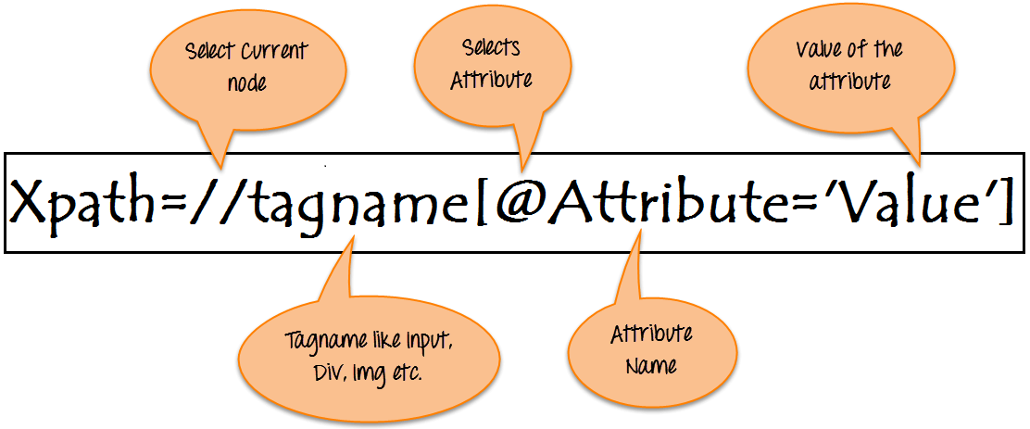
Syntax for XPath:
XPath contains the path of the element situated at the web page. Standard syntax for creating XPath is.
Xpath=//tagname[@attribute='value']
- // : Select current node.
- Tagname: Tagname of the particular node.
- @: Select attribute.
- Attribute: Attribute name of the node.
- Value: Value of the attribute.
To find the element on web pages accurately there are different types of locators:
XPath Locators | Find different elements on web page
ID | To find the element by ID of the element
Classname | To find the element by Classname of the element
Name | To find the element by name of the element
Link text | To find the element by text of the link
XPath | XPath required for finding the dynamic element and traverse between various elements of the web page
CSS path | CSS path also locates elements having no name, class or ID.

Types of X-path
There are two types of XPath:
1) Absolute XPath .
2) Relative XPath .
Absolute XPath :
It is the direct way to find the element, but the disadvantage of the absolute XPath is that if there are any changes made in the path of the element then that XPath gets failed.
The key characteristic of XPath is that it begins with the single forward slash(/) ,which means you can select the element from the root node.
Below is the example of an absolute xpath expression of the element shown in the below screen.
Absolute xpath:
html/body/div[1]/section/div[1]/div/div/div/div[1]/div/div/div/div/div[3]/div[1]/div/h4[1]/b
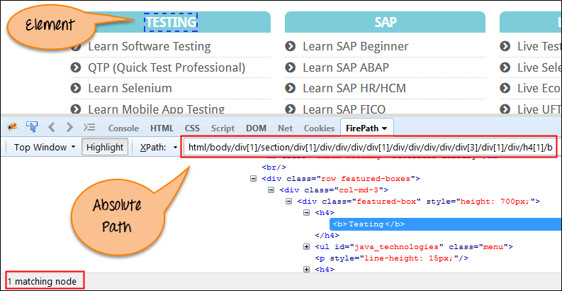
Relative xpath:
For Relative Xpath the path starts from the middle of the HTML DOM structure. It starts with the double forward slash (//), which means it can search the element anywhere at the webpage.
You can start from the middle of the HTML DOM structure and no need to write long xpath.
Below is the example of a relative XPath expression of the same element shown in the below screen. This is the common format used to find element through a relative XPath.
Relative xpath: //*[@class='featured-box']//*[text()='Testing']
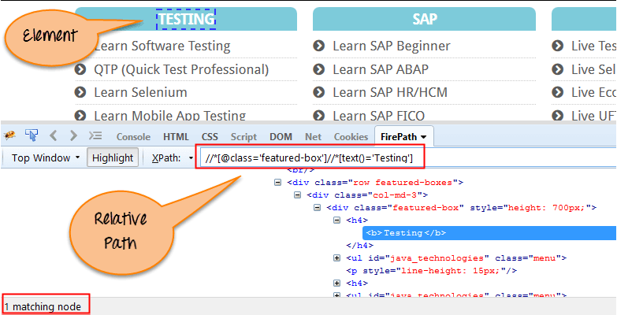
What are XPath axes.
XPath axes search different nodes in XML document from current context node. XPath Axes are the methods used to find dynamic elements, which otherwise not possible by normal XPath method having no ID , Classname, Name, etc.
Axes methods are used to find those elements, which dynamically change on refresh or any other operations. There are few axes methods commonly used in Selenium Webdriver like child, parent, ancestor, sibling, preceding, self, etc.

Using XPath Handling complex & Dynamic elements in Selenium

1) Basic XPath:
XPath expression select nodes or list of nodes on the basis of attributes like ID , Name, Classname, etc. from the XML document as illustrated below.
Xpath=//input[@name='uid']
Here is a link to access the page http://demo.guru99.com/v1/
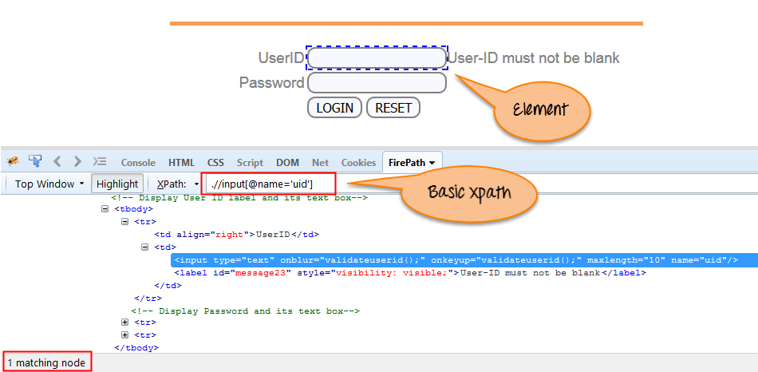
Some more basic xpath expressions:
Xpath=//input[@type='text']
Xpath= //label[@id='message23']
Xpath= //input[@value='RESET']
Xpath=//*[@class='barone']
Xpath=//a[@href='http://demo.guru99.com/']
Xpath= //img[@src='//cdn.guru99.com/images/home/java.png']
2) Contains() : Contains() is a method used in XPath expression. It is used when the value of any attribute changes dynamically, for example, login information.
The contain feature has an ability to find the element with partial text as shown in below example.
In this example, we tried to identify the element by just using partial text value of the attribute. In the below XPath expression partial value 'sub' is used in place of submit button. It can be observed that the element is found successfully.
Complete value of 'Type' is 'submit' but using only partial value 'sub'.
Xpath=//*[contains(@type,'sub')]
Complete value of 'name' is 'btnLogin' but using only partial value 'btn'.
Xpath=.//*[contains(@name,'btn')]
In the above expression, we have taken the 'name' as an attribute and 'btn' as an partial value as shown in the below screenshot. This will find 2 elements (LOGIN & RESET) as their 'name' attribute begins with 'btn'.
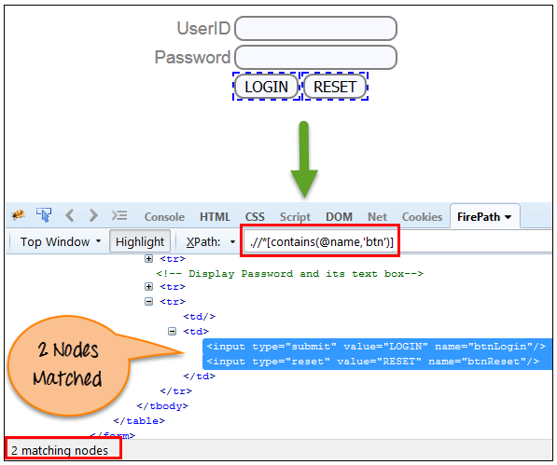
Similarly, in the below expression, we have taken the 'id' as an attribute and 'message' as a partial value. This will find 2 elements ('User-ID must not be blank' & 'Password must not be blank') as its 'name' attribute begins with 'message'.
Xpath=//*[contains(@id,'message')]
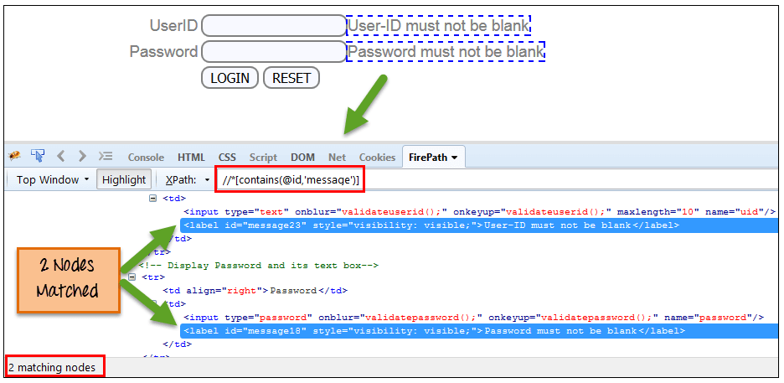
In the below expression, we have taken the "text" of the link as an attribute and 'here' as a partial value as shown in the below screenshot. This will find the link ('here') as it displays the text 'here'.
Xpath=//*[contains(text(),'here')]
Xpath=//*[contains(@href,'guru99.com')]
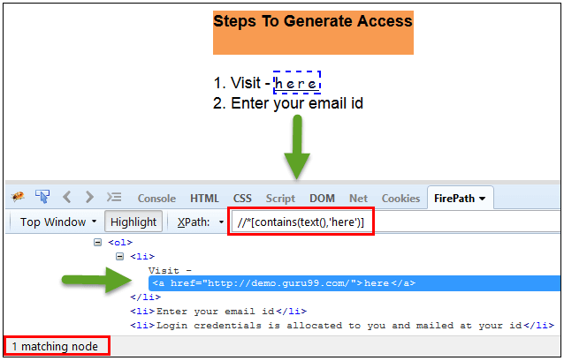

3) Using OR & AND:
In OR expression, two conditions are used, whether 1st condition OR 2nd condition should be true. It is also applicable if any one condition is true or maybe both. Means any one condition should be true to find the element.
In the below XPath expression, it identifies the elements whose single or both conditions are true.
Xpath=//*[@type='submit' OR @name='btnReset']
Highlighting both elements as "LOGIN " element having attribute 'type' and "RESET" element having attribute 'name'.
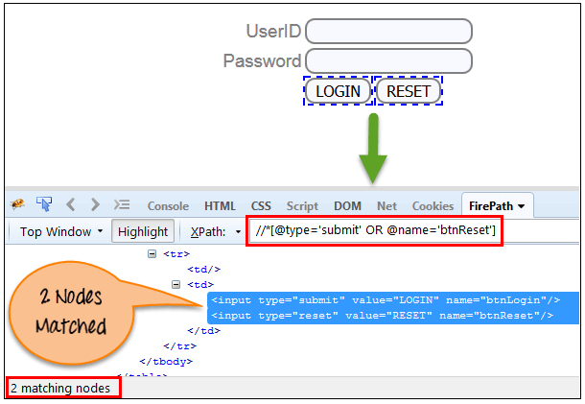
In AND expression, two conditions are used, both conditions should be true to find the element. It fails to find element if any one condition is false.
Xpath=//input[@type='submit' AND @name='btnLogin']
In below expression, highlighting 'LOGIN' element as it having both attribute 'type' and 'name'.
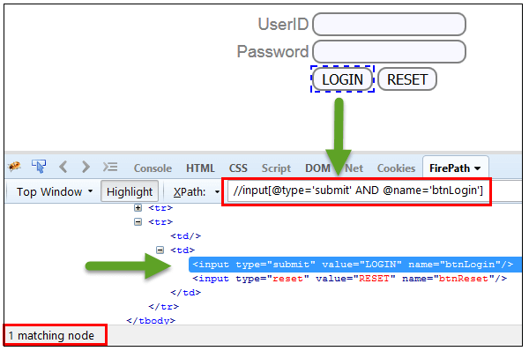
4) Start-with function: Start-with function finds the element whose attribute value changes on refresh or any operation on the webpage. In this expression, match the starting text of the attribute is used to find the element whose attribute changes dynamically. You can also find the element whose attribute value is static (not changes).
For example -: Suppose the ID of particular element changes dynamically like:
Id=" message12"
Id=" message345"
Id=" message8769"
and so on.. but the initial text is same. In this case, we use Start-with expression.
In the below expression, there are two elements with an id starting "message"(i.e., 'User-ID must not be blank' & 'Password must not be blank'). In below example, XPath finds those element whose 'ID' starting with 'message'.
Xpath=//label[starts-with(@id,'message')]
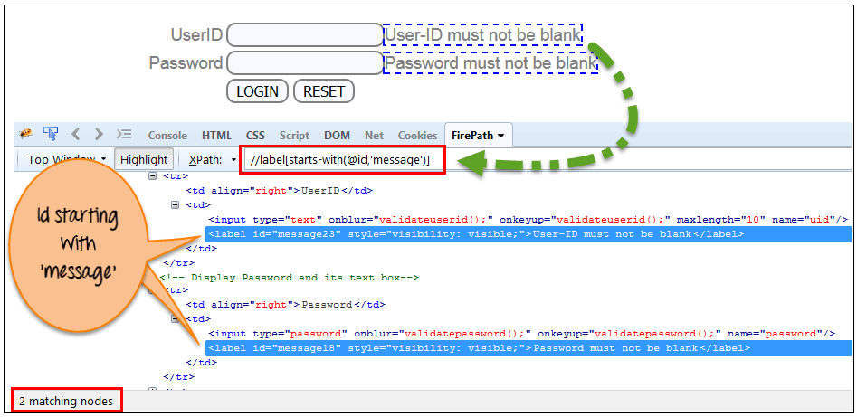
5) Text(): In this expression, with text function, we find the element with exact text match as shown below. In our case, we find the element with text "UserID".
Xpath=//td[text()='UserID']
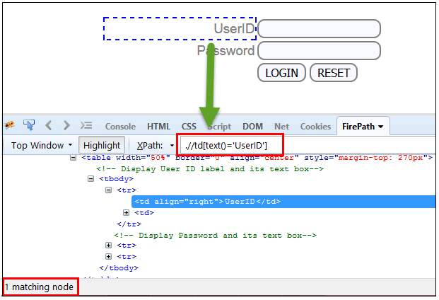
6) XPath axes methods: These XPath axes methods are used to find the complex or dynamic elements. Below we will see some of these methods.
For illustrating these XPath axes method, we will use the Guru99 bank demo site.
a) Following: Selects all elements in the document of the current node( ) [ UserID input box is the current node] as shown in the below screen.
Xpath=//*[@type='text']//following::input
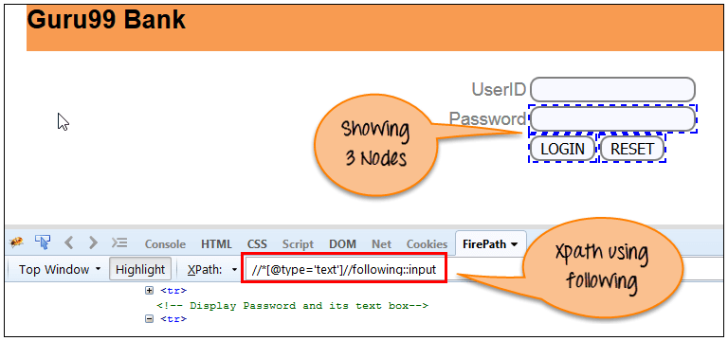
There are 3 "input" nodes matching by using "following" axis- password, login and reset button. If you want to focus on any particular element then you can use the below XPath method:
Xpath=//*[@type='text']//following::input[1]
You can change the XPath according to the requirement by putting [1],[2]…………and so on.
With the input as '1', the below screen shot finds the particular node that is 'Password' input box element.
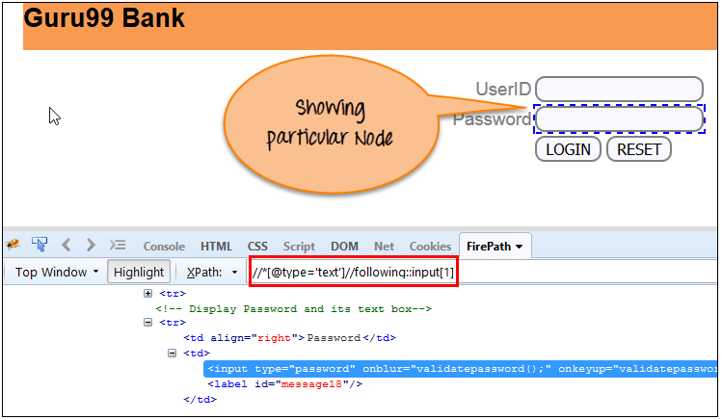
b) Ancestor: The ancestor axis selects all ancestors element (grandparent, parent, etc.) of the current node as shown in the below screen.
In the below expression, we are finding ancestors element of the current node("ENTERPRISE TESTING" node).
Xpath=//*[text()='Enterprise Testing']//ancestor::div
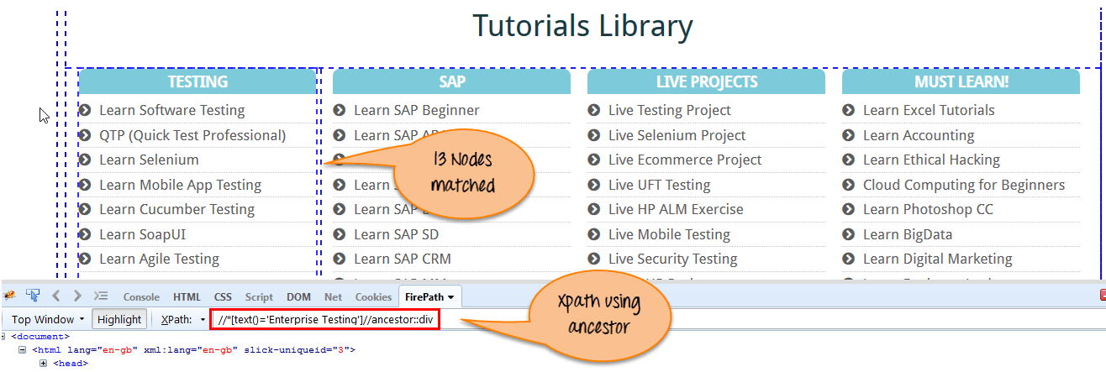
There are 13 "div" nodes matching by using "ancestor" axis. If you want to focus on any particular element then you can use the below XPath, where you change the number 1, 2 as per your requirement:
Xpath=//*[text()='Enterprise Testing']//ancestor::div[1]
You can change the XPath according to the requirement by putting [1], [2]…………and so on.
c) Child : Selects all children elements of the current node (Java) as shown in the below screen.
Xpath=//*[@id='java_technologies']/child::li
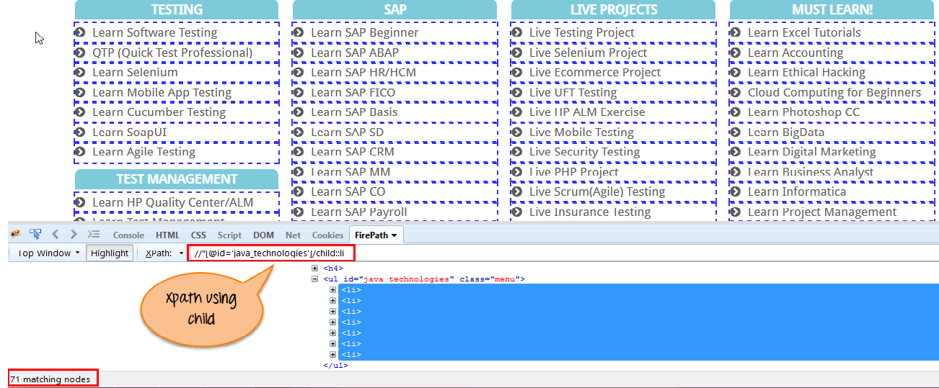
There are 71 "li" nodes matching by using "child" axis. If you want to focus on any particular element then you can use the below xpath:
Xpath=//*[@id='java_technologies']/child::li[1]
You can change the xpath according to the requirement by putting [1],[2]…………and so on.
d) Preceding: Select all nodes that come before the current node as shown in the below screen.
In the below expression, it identifies all the input elements before "LOGIN" button that is Userid and password input element.
Xpath=//*[@type='submit']//preceding::input
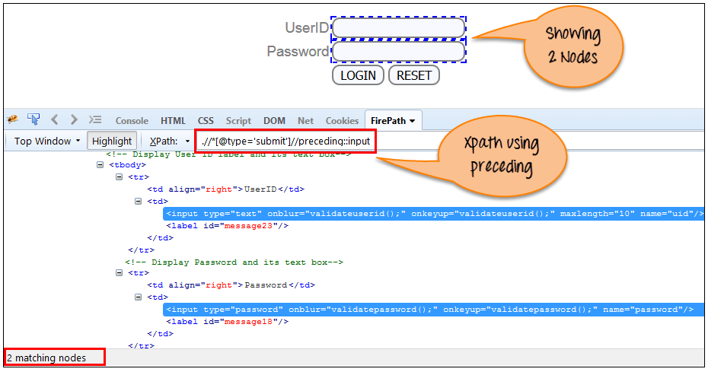
There are 2 "input" nodes matching by using "preceding" axis. If you want to focus on any particular element then you can use the below XPath:
Xpath=//*[@type='submit']//preceding::input[1]
You can change the xpath according to the requirement by putting [1],[2]…………and so on.
e) Following-sibling: Select the following siblings of the context node. Siblings are at the same level of the current node as shown in the below screen. It will find the element after the current node.
xpath=//*[@type='submit']//following-sibling::input
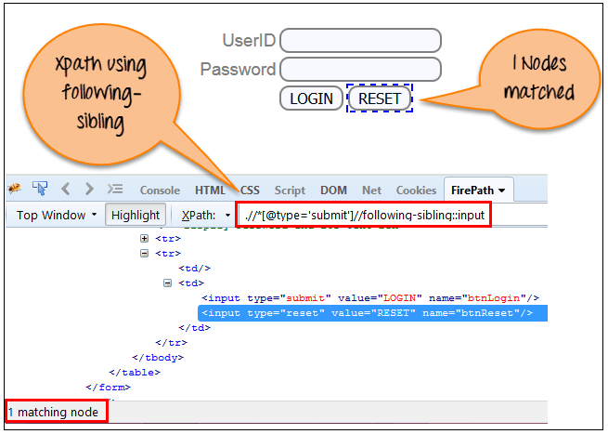
One input nodes matching by using "following-sibling" axis.
f) Parent: Selects the parent of the current node as shown in the below screen.
Xpath=//*[@id='rt-feature']//parent::div
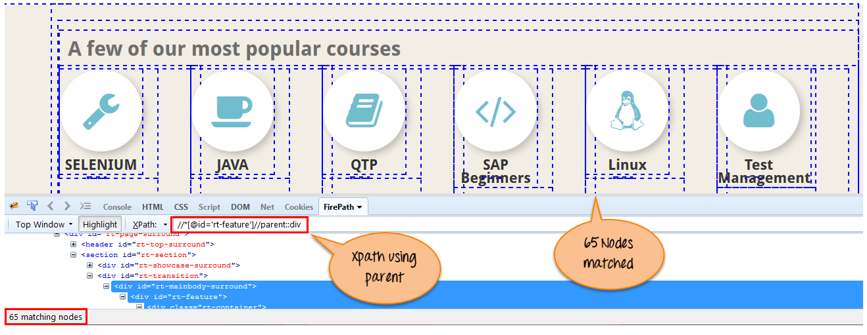
There are 65 "div" nodes matching by using "parent" axis. If you want to focus on any particular element then you can use the below XPath:
Xpath=//*[@id='rt-feature']//parent::div[1]
You can change the XPath according to the requirement by putting [1],[2]…………and so on.
g) Self: Selects the current node or 'self' means it indicates the node itself as shown in the below screen.
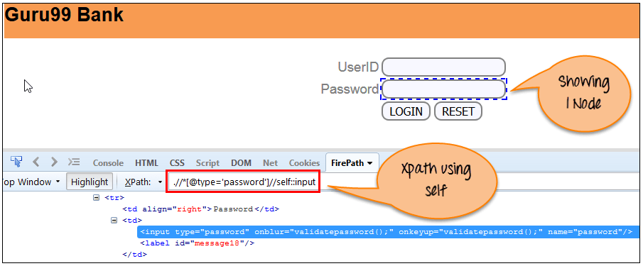
One node matching by using "self " axis. It always finds only one node as it represents self-element.
Xpath =//*[@type='password']//self::input
h) Descendant: Selects the descendants of the current node as shown in the below screen.
In the below expression, it identifies all the element descendants to current element ( 'Main body surround' frame element) which means down under the node (child node , grandchild node, etc.).
Xpath=//*[@id='rt-feature']//descendant::a
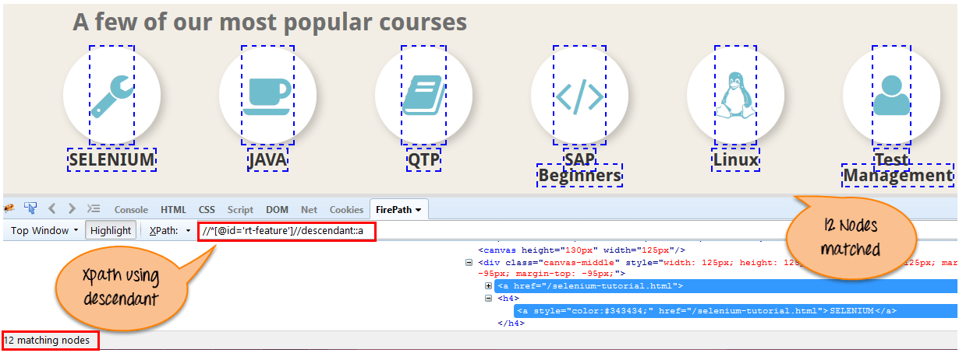
There are 12 "link" nodes matching by using "descendant" axis. If you want to focus on any particular element then you can use the below XPath:
Xpath=//*[@id='rt-feature']//descendant::a[1]
You can change the XPath according to the requirement by putting [1],[2]…………and so on.
Summary:
XPath is required to find an element on the web page as to do an operation on that particular element.
- There are two types of XPath:
  - Absolute XPath
  - Relative XPath
- XPath Axes are the methods used to find dynamic elements, which otherwise not possible to find by normal XPath method
- XPath expression select nodes or list of nodes on the basis of attributes like ID , Name, Classname, etc. from the XML document .

ID and XPath:
import org.openqa.selenium.By;
import org.openqa.selenium.WebDriver;
import org.openqa.selenium.firefox.FirefoxDriver;

public class IdXPATHDemo {

public static void main(String[] args) {
WebDriver driver;
driver = new FirefoxDriver();
String baseURL = "http://www.google.com";
driver.manage().window().maximize();
driver.get(baseURL);

driver.findElement(By.id("lst-ib")).sendKeys("letskodeit");
driver.findElement(By.xpath("//*[@id='sblsbb']/button")).click();
}

}

Interview questions:

Name:
package basicweb;

import org.openqa.selenium.By;
import org.openqa.selenium.WebDriver;
import org.openqa.selenium.firefox.FirefoxDriver;

public class IdNameDemo {

public static void main(String[] args) {
WebDriver driver;
driver = new FirefoxDriver();
String baseURL = "http://www.google.com";
driver.manage().window().maximize();
driver.get(baseURL);

driver.findElement(By.id("lst-ib")).sendKeys("letskodeit");
driver.findElement(By.name("btnG")).click();
}

}

Link text and Partial link text
<a> tag is used for hyperlinks in HTML. This is why it is known as link.
Selenium WebDriver functionality to find element with link text or partial link text works if the text
is inside <a> tag.
For any other tag, we need to build XPath/CSS. For reference, CSS/XPath is covered in
lectures 63 - 75.
The website used for the demo for next lecture has been uploaded a little bit.
Previously the text of the Menu items used to be inside <a> tag.
After the update, text of the Menu items are inside <span> tag.
The current code will not work because of that. But the most important things is that the concept
stays the same.
You should be able to use the same concept on any website where you can find a link with text
inside it.
You need to look at the DOM and make sure that text is within <a> tag.
Google.com is an example, there is a Gmail link on the right hand side and the text is inside <a>
tag. It may change in the future if google makes an update but I wanted to make sure that you
understand the concept and do not reply on any particular website for practice.
package basicweb;

import org.openqa.selenium.By;
import org.openqa.selenium.WebDriver;
import org.openqa.selenium.firefox.FirefoxDriver;

public class FindByLinkText {

public static void main(String[] args) throws Exception {
WebDriver driver;
driver = new FirefoxDriver();
String baseURL = "http://demostore.x-cart.com/";
driver.manage().window().maximize();
driver.get(baseURL);

driver.findElement(By.linkText("Shipping")).click();
Thread.sleep(2000);

driver.findElement(By.partialLinkText("Contact")).click();

}
}

Class Name:
package basicweb;

import org.openqa.selenium.By;
import org.openqa.selenium.WebDriver;
import org.openqa.selenium.firefox.FirefoxDriver;

public class FindByClassName {

public static void main(String[] args) throws Exception {
WebDriver driver;
driver = new FirefoxDriver();
String baseURL = "http://demostore.x-cart.com/";
driver.manage().window().maximize();
driver.get(baseURL);

driver.findElement(By.className("title")).click();

driver.findElement(By.className("leaf")).click();
}
}
Tag Name:
package basicweb;

import org.openqa.selenium.By;
import org.openqa.selenium.WebDriver;
import org.openqa.selenium.firefox.FirefoxDriver;

public class FindByTagName {

public static void main(String[] args) throws Exception {
WebDriver driver;
driver = new FirefoxDriver();

String baseURL = "http://demostore.x-cart.com/";
driver.manage().window().maximize();
driver.get(baseURL);

driver.findElement(By.tagName("a")).click();

// id - fastest
// name
// classname
// xpath
// linktext
// partial link text
// tagname
// css selector
}
}
CSS:
CSS Selectors Cheat Sheet
Every element does not have an id--‐>static id, unique name, unique link text. For those elements we need to build xpath to find and then perform actions on them.
Whatever we use to find an element, id, name, xpath, css --‐> It should always be unique. It should only find one matching node unless we want to capture a list of elements.
Syntax:
tag[attribute='value']
“#” --‐>Id
“.” --‐>Class
Element Displayed Example Text Box:
input[id=displayed--‐text]
#displayed--‐text
input#displayed--‐text
input[class=displayed--‐class]
.displayed--‐class
input.displayed--‐class
Appending Classes
.class1.class2.class3 --‐> Until we find a unique element
Using wildcards in CSS Selectors:
“^”--‐> Represents the starting text
“$” --‐> Represents the ending text
“*” --‐> Represents the text contained
Syntax:
tag[attribute<special character>=’value’]

Examples:
input[class='inputs'] --‐> Only 1 matching node
input[class^='inputs'] --‐> Two matching nodes
input[class='displayed--‐class'] --‐ No matching nodes
input[class$='class'] --‐> One matching node
input[class*='displayed--‐class'] --‐> One matching node
Finding Children
Fieldset --‐> 10 matching nodes
Fieldset>table
fieldset>#product --‐> One matching node
fieldset>button --‐> One matching node
Fieldset>a
fieldset>input#name
XPATH Cheat Sheet
Every element does not have an id --‐> static id, unique name, unique link text. For those elements we need to build xpath to find and then perform actions on them.
Whatever we use to find an element, id, name, xpath --‐> It should always be unique.
It should only find one matching node unless we want to capture a list of elements.
Difference between single ‘/’ or double ‘//’ Single slash ‘/’ anywhere in xpath signifies to look for the element immediately inside the parent element.
Double slash ‘//’ signifies to look for any child or nested--‐ child element inside the parent element.
Syntax:
//tag[@attribute='value']
Relative xpath using single ‘/’ for Login link
//div[@id='navbar']/div/div/div/ul/li[2]/a
Relative xpath using double ‘//’ for Login link.
//div[@id='navbar']//ul/li[2]/a
Don’t use “*”, always use the tag name. Using Text of the element to build xpath Finding Login link:
//div[@class='homepage--‐hero']//a[text()='Enroll
now']
Using Contains to find the elements:
Syntax:
//tag[contains(attribute,‘value’)]
Finding Login link:
//div[@id='navbar']//a[contains(text(),'Login')]
//div[@id='navbar']//a[contains(@class,'navbar--‐link')
and
contains(@href,'sign_in')]
Using Starts--‐With to find the elements:
Syntax:
//tag[starts--‐with(attribute,
‘value’)]
Finding Login link:
//div[@id='navbar']//a[starts--‐with(@class,'navbar--‐link')]
Parent Syntax:
xpath--‐to--‐some--‐element//parent::<tag>
Preceding Sibling Syntax:
xpath--‐to--‐some--‐element//preceding--‐sibling::<tag>
Following Sibling Syntax:
xpath--‐to--‐some--‐element//following--‐sibling::<tag>

Synchronization:

Selenium WebDriver has borrowed the idea of implicit waits from Watir. This means that we can tell Selenium that we would like it to wait for a certain amount of time before throwing an exception that it cannot find the element on the page. We should note that implicit waits will be in place for the entire time the browser is open. This means that any search for elements on the page could take the time the implicit wait is set for.
1  2  3  4  5  6  7 | WebDriver driver = new FirefoxDriver();  driver.manage().timeouts().implicitlyWait(10, TimeUnit.SECONDS);  driver.get("http://url_that_delays_loading");  WebElement myDynamicElement = driver.findElement(By.id("myDynamicElement"));

Fluent Wait
Each FluentWait instance defines the maximum amount of time to wait for a condition, as well as the frequency with which to check the condition. Furthermore, the user may configure the wait to ignore specific types of exceptions whilst waiting, such as NoSuchElementExceptions when searching for an element on the page.

1  2  3  4  5  6  7  8  9  10  11  12  13  14  15  16  17  18  19  20  21 | // Waiting 30 seconds for an element to be present on the page, checking  // for its presence once every 5 seconds.  Wait wait = new FluentWait(driver)  .withTimeout(30, SECONDS)  .pollingEvery(5, SECONDS)  .ignoring(NoSuchElementException.class);  WebElement foo = wait.until(new Function() {  public WebElement apply(WebDriver driver) {  return driver.findElement(By.id("foo"));  }  });

Explicit Wait
It is more extendible in the means that you can set it up to wait for any condition you might like. Usually, you can use some of the prebuilt ExpectedConditions to wait for elements to become clickable, visible, invisible, etc.

1  2  3 | WebDriverWait wait = new WebDriverWait(driver, 10);  WebElement element = wait.until(ExpectedConditions.elementToBeClickable(By.id("someid")));

Difference Between Implicit, Explicit and Fluent Wait
Implicit Wait: During Implicit wait if the Web Driver cannot find it immediately because of its availability, it will keep polling (around 250 milli seconds) the DOM to get the element. If the element is not available within the specified Time an NoSuchElementException will be raised. The default setting is zero. Once we set a time, the Web Driver waits for the period of the WebDriver object instance.
Explicit Wait: There can be instance when a particular element takes more than a minute to load. In that case you definitely not like to set a huge time to Implicit wait, as if you do this your browser will going to wait for the same time for every element.
To avoid that situation you can simply put a separate time on the required element only. By following this your browser implicit wait time would be short for every element and it would be large for specific element.
Fluent Wait: Let’s say you have an element which sometime appears in just 1 second and some time it takes minutes to appear. In that case it is better to use fluent wait, as this will try to find element again and again until it find it or until the final timer runs out.
Solutions: We always get confuse when it comes to using Wait commands, to better understand it we need to remember that there is a difference between several scenarios:
An element not being present at all in the DOM.
An element being present in the DOM but not visible.
An element being present in the DOM but not enabled. (i.e. clickable)
There are pages which get displayed with the JavaScript, the elements are already present in the browser DOM, but are not visible. The implicit wait only waits for an element to appear in the DOM, so it returns immediately, but when you try to interact with the element you get a NoSuchElementException. You could test this hypothesis by writing a helper method that explicit wait for an element to be visible or clickable.

1  2  3  4  5  6  7  8  9  10  11 | public WebElement getWhenVisible(By locator, int timeout) {  WebElement element = null;  WebDriverWait wait = new WebDriverWait(driver, timeout);  element = wait.until(ExpectedConditions.visibilityOfElementLocated(locator));  return element;  }

1  2  3  4  5  6  7  8  9  10  11 | public void clickWhenReady(By locator, int timeout) {  WebElement element = null;  WebDriverWait wait = new WebDriverWait(driver, timeout);  element = wait.until(ExpectedConditions.elementToBeClickable(locator));  element.click();  }

Junit:
- @BeforeClass – Run once before any of the test methods in the class, public static void
- @AfterClass – Run once after all the tests in the class have been run, public static void
- @Before – Run before @Test, public void
- @After – Run after @Test, public void
- @Test – This is the test method to run, public void

Selenium Test:
package basicweb;

import java.util.concurrent.TimeUnit;

import org.junit.After;
import org.junit.Before;
import org.junit.Test;
import org.openqa.selenium.By;
import org.openqa.selenium.WebDriver;
import org.openqa.selenium.firefox.FirefoxDriver;

public class SeleniumTest {
private WebDriver driver;
private String baseUrl;

@Before
public void setUp() throws Exception {
driver = new FirefoxDriver();
baseUrl = "http://www.letskodeit.com/";
driver.manage().timeouts().implicitlyWait(30, TimeUnit.SECONDS);
driver.manage().window().maximize();
}

@Test
public void testSelenium() throws Exception {
driver.get(baseUrl + "/");
driver.findElement(By.id("i90scv3glabel")).click();
driver.findElement(By.linkText("Practice")).click();
}

@After
public void tearDown() throws Exception {
Thread.sleep(3000);
// driver.quit();
}
}

Basic actions:
package basicweb;

import java.util.concurrent.TimeUnit;

import org.junit.After;
import org.junit.Before;
import org.junit.Test;
import org.openqa.selenium.By;
import org.openqa.selenium.WebDriver;
import org.openqa.selenium.firefox.FirefoxDriver;

public class BasicActions {
WebDriver driver;
String baseUrl;

@Before
public void setUp() throws Exception {
driver = new FirefoxDriver();
baseUrl = "http://letskodeit.teachable.com/";
driver.manage().timeouts().implicitlyWait(10, TimeUnit.SECONDS);
driver.manage().window().maximize();
}

@Test
public void test() {
driver.get(baseUrl);
driver.findElement(By.xpath("//div[@id='navbar']//a[@href='/sign_in']")).click();
System.out.println("Clicked on login");
driver.findElement(By.id("user_email")).sendKeys("test@email.com");
System.out.println("Sending keys to username field");
driver.findElement(By.id("user_password")).sendKeys("test");
System.out.println("Sending keys to password field");
driver.findElement(By.id("user_email")).clear();
System.out.println("Clearing the username field");
}

@After
public void tearDown() throws Exception {
// driver.quit();
}
}
Navigation:
package basicweb;

import java.util.concurrent.TimeUnit;

import org.junit.After;
import org.junit.Before;
import org.junit.Test;
import org.openqa.selenium.WebDriver;
import org.openqa.selenium.firefox.FirefoxDriver;

public class NavigatingBetweenPages {
WebDriver driver;
String baseUrl;

@Before
public void setUp() throws Exception {
driver = new FirefoxDriver();
baseUrl = "http://letskodeit.teachable.com/";
driver.manage().timeouts().implicitlyWait(10, TimeUnit.SECONDS);
driver.manage().window().maximize();
}

@Test
public void test() throws InterruptedException {
driver.get(baseUrl);
String title = driver.getTitle();
System.out.println("Title of the page is: " + title);

String currentUrl = driver.getCurrentUrl();
System.out.println("Current URL is: " + currentUrl);

String urlToNavigate = "https://sso.teachable.com/secure/42299/users/sign_in?reset_purchase_session=1";
driver.navigate().to(urlToNavigate);
System.out.println("Navigating To Login");
currentUrl = driver.getCurrentUrl();
System.out.println("Current URL is: " + currentUrl);

Thread.sleep(2000);

driver.navigate().back();
System.out.println("Navigate Back");
currentUrl = driver.getCurrentUrl();
System.out.println("Current URL is: " + currentUrl);

Thread.sleep(2000);

driver.navigate().forward();
System.out.println("Navigate Forward");
currentUrl = driver.getCurrentUrl();
System.out.println("Current URL is: " + currentUrl);

Thread.sleep(2000);

driver.navigate().back();
System.out.println("Navigate Back");
currentUrl = driver.getCurrentUrl();
System.out.println("Current URL is: " + currentUrl);

driver.navigate().refresh();
System.out.println("Navigate Refresh");
driver.get(currentUrl);
System.out.println("Navigate Refresh");

String pageSource = driver.getPageSource();
System.out.println(pageSource);
}

@After
public void tearDown() throws Exception {
// driver.quit();
}
}
Element State:
package workingwithelements;

import java.util.concurrent.TimeUnit;

import org.junit.After;
import org.junit.Before;
import org.junit.Test;
import org.openqa.selenium.By;
import org.openqa.selenium.WebDriver;
import org.openqa.selenium.WebElement;
import org.openqa.selenium.firefox.FirefoxDriver;

public class ElementState {
WebDriver driver;
String baseUrl;

@Before
public void setUp() throws Exception {
driver = new FirefoxDriver();
baseUrl = "https://www.google.com";
driver.manage().timeouts().implicitlyWait(10, TimeUnit.SECONDS);
driver.manage().window().maximize();
driver.get(baseUrl);
}

@Test
public void test() {
WebElement e1 = driver.findElement(By.id("gs_htif0"));
System.out.println("E1 is Enabled? " + e1.isEnabled());

WebElement e2 = driver.findElement(By.id("gs_taif0"));
System.out.println("E2 is Enabled? " + e2.isEnabled());

WebElement e3 = driver.findElement(By.id("lst-ib"));
System.out.println("E3 is Enabled? " + e3.isEnabled());

e3.sendKeys("letskodeit");
}

@After
public void tearDown() throws Exception {
Thread.sleep(2000);
driver.quit();
}
}
Radio Buttons and checkboxes:
package workingwithelements;

import java.util.concurrent.TimeUnit;

import org.junit.After;
import org.junit.Before;
import org.junit.Test;
import org.openqa.selenium.By;
import org.openqa.selenium.WebDriver;
import org.openqa.selenium.WebElement;
import org.openqa.selenium.firefox.FirefoxDriver;

public class RadioButtonsAndCheckBoxes {
WebDriver driver;
String baseUrl;

@Before
public void setUp() throws Exception {
driver = new FirefoxDriver();
baseUrl = "http://letskodeit.teachable.com/pages/practice";
driver.manage().timeouts().implicitlyWait(10, TimeUnit.SECONDS);
driver.manage().window().maximize();
driver.get(baseUrl);
}

@Test
public void test() throws InterruptedException {
WebElement bmwRadioBtn = driver.findElement(By.id("bmwradio"));
bmwRadioBtn.click();

Thread.sleep(2000);
WebElement benzRadioBtn = driver.findElement(By.id("benzradio"));
benzRadioBtn.click();

Thread.sleep(2000);
WebElement bmwCheckBox = driver.findElement(By.id("bmwcheck"));
bmwCheckBox.click();

Thread.sleep(2000);
WebElement benzCheckBox = driver.findElement(By.id("benzcheck"));
benzCheckBox.click();

System.out.println("BMW Radio Button is selected? " + bmwRadioBtn.isSelected());
System.out.println("Benz Radio Button is selected? " + benzRadioBtn.isSelected());
System.out.println("BMW Checkbox is selected? " + bmwCheckBox.isSelected());
System.out.println("Benz Checkbox is selected? " + benzCheckBox.isSelected());
}

@After
public void tearDown() throws Exception {
Thread.sleep(3000);
//driver.quit();
}
}
WebElement List:
package workingwithelements;

import java.util.List;
import java.util.concurrent.TimeUnit;
import org.junit.After;
import org.junit.Before;
import org.junit.Test;
import org.openqa.selenium.By;
import org.openqa.selenium.WebDriver;
import org.openqa.selenium.WebElement;
import org.openqa.selenium.firefox.FirefoxDriver;

public class WorkingWithElementsList {
private WebDriver driver;
private String baseUrl;

@Before
public void setUp() throws Exception {
driver = new FirefoxDriver();
baseUrl = "http://letskodeit.teachable.com/pages/practice";

// Maximize the browser's window
driver.manage().window().maximize();
driver.manage().timeouts().implicitlyWait(10, TimeUnit.SECONDS);
driver.get(baseUrl);
}

@Test
public void testListOfElements() throws Exception {
boolean isChecked = false;
List<WebElement> radioButtons = driver.findElements(
By.xpath("//input[contains(@type,'radio') and contains(@name,'cars')]"));
int size = radioButtons.size();
System.out.println("Size of the list: " + size);
for (int i=0; i<size; i++) {
isChecked = radioButtons.get(i).isSelected();

if (!isChecked) {
radioButtons.get(i).click();
Thread.sleep(2000);
}
}
}

@After
public void tearDown() throws Exception {
Thread.sleep(2000);
driver.quit();
}

}
Dropdown list:
package workingwithelements;

import java.util.concurrent.TimeUnit;
import java.util.*;
import org.junit.After;
import org.junit.Before;
import org.junit.Test;
import org.openqa.selenium.By;
import org.openqa.selenium.WebDriver;
import org.openqa.selenium.WebElement;
import org.openqa.selenium.firefox.FirefoxDriver;
import org.openqa.selenium.support.ui.Select;

public class DropdownSelect {
private WebDriver driver;
private String baseUrl;

@Before
public void setUp() throws Exception {
System.setProperty("webdriver.gecko.driver",
"/Users/atomar/Documents/workspace_personal/libs/geckodriver");
driver = new FirefoxDriver();
baseUrl = "https://letskodeit.teachable.com/p/practice";

// Maximize the browser's window
driver.manage().window().maximize();
driver.manage().timeouts().implicitlyWait(10, TimeUnit.SECONDS);
}

@Test
public void testDropdown() throws Exception {
driver.get(baseUrl);
WebElement element = driver.findElement(By.id("carselect"));
Select sel = new Select(element);

Thread.sleep(2000);
System.out.println("Select Benz by value");
sel.selectByValue("benz");

Thread.sleep(2000);
System.out.println("Select Honda by index");
sel.selectByIndex(2);

Thread.sleep(2000);
System.out.println("Select BMW by visible text");
sel.selectByVisibleText("BMW");

Thread.sleep(2000);
System.out.println("Print the list of all options");
List<WebElement> options = sel.getOptions();
int size = options.size();

for (int i=0; i<size; i++) {
String optionName = options.get(i).getText();
System.out.println(optionName);
}
}

@After
public void tearDown() throws Exception {
Thread.sleep(2000);
driver.quit();
}
}

MultiSelect
package workingwithelements;

import java.util.concurrent.TimeUnit;
import java.util.*;

import org.junit.After;
import org.junit.Before;
import org.junit.Test;
import org.openqa.selenium.By;
import org.openqa.selenium.WebDriver;
import org.openqa.selenium.WebElement;
import org.openqa.selenium.firefox.FirefoxDriver;
import org.openqa.selenium.support.ui.Select;

public class MultipleSelect {
private WebDriver driver;
private String baseUrl;

@Before
public void setUp() throws Exception {
System.setProperty("webdriver.gecko.driver",
"/Users/atomar/Documents/workspace_personal/libs/geckodriver");
driver = new FirefoxDriver();
baseUrl = "https://letskodeit.teachable.com/p/practice";

// Maximize the browser's window
driver.manage().window().maximize();
driver.manage().timeouts().implicitlyWait(10, TimeUnit.SECONDS);
}

@Test
public void testMultiSelect() throws Exception {
driver.get(baseUrl);
WebElement element = driver.findElement(By.id("multiple-select-example"));
Select sel = new Select(element);

Thread.sleep(2000);
System.out.println("Select orange by value");
sel.selectByValue("orange");

Thread.sleep(2000);
System.out.println("De-select orange by value");
sel.deselectByValue("orange");

Thread.sleep(2000);
System.out.println("Select peach by index");
sel.selectByIndex(2);

Thread.sleep(2000);
System.out.println("Select Apple by visible text");
sel.selectByVisibleText("Apple");

Thread.sleep(2000);
System.out.println("Print all selected options");
List<WebElement> selectedOptions = sel.getAllSelectedOptions();
for (WebElement option : selectedOptions) {
System.out.println(option.getText());
}

Thread.sleep(2000);
System.out.println("De-select all selected options");
sel.deselectAll();
}

@After
public void tearDown() throws Exception {
Thread.sleep(2000);
driver.quit();
}
}

Hidden elements:
package workingwithelements;

import java.util.concurrent.TimeUnit;

import org.junit.After;
import org.junit.Before;
import org.junit.Test;
import org.openqa.selenium.By;
import org.openqa.selenium.JavascriptExecutor;
import org.openqa.selenium.WebDriver;
import org.openqa.selenium.WebElement;
import org.openqa.selenium.firefox.FirefoxDriver;

public class ElementDisplayed {
WebDriver driver;
// Adding code for JS
private JavascriptExecutor js;
String baseUrl1;
String baseUrl2;

@Before
public void setUp() throws Exception {
driver = new FirefoxDriver();
// Adding code for JS
js = (JavascriptExecutor) driver;
baseUrl1 = "http://letskodeit.teachable.com/pages/practice";
baseUrl2 = "http://www.expedia.com";
driver.manage().timeouts().implicitlyWait(2, TimeUnit.SECONDS);
driver.manage().window().maximize();
}
@Test
public void testLetsKodeIt() throws InterruptedException {
driver.get(baseUrl1);

WebElement textBox = driver.findElement(By.id("displayed-text"));
System.out.println("Text Box Displayed: " + textBox.isDisplayed());

Thread.sleep(3000);

WebElement hideButton = driver.findElement(By.id("hide-textbox"));
hideButton.click();
System.out.println("Clicked on hide button");
System.out.println("Text Box Displayed: " + textBox.isDisplayed());

Thread.sleep(3000);

// Added code to scroll up because the element was hiding behind the top navigation menu
// You will learn about scrolling in future lecture
js.executeScript("window.scrollBy(0, -190);");
WebElement showButton = driver.findElement(By.id("show-textbox"));
showButton.click();
System.out.println("Clicked on show button");
System.out.println("Text Box Displayed: " + textBox.isDisplayed());
}

@Test
public void testExpedia() throws InterruptedException {
driver.get(baseUrl2);

WebElement childDropdown = driver.findElement(By.id("package-1-age-select-1"));
System.out.println("Child Drpdown Displayed: " + childDropdown.isDisplayed());
}

@After
public void tearDown() throws Exception {
Thread.sleep(2000);
driver.quit();
}
}

Get text:
package usefulmethods;

import java.util.concurrent.TimeUnit;

import org.junit.After;
import org.junit.Before;
import org.junit.Test;
import org.openqa.selenium.By;
import org.openqa.selenium.WebDriver;
import org.openqa.selenium.WebElement;
import org.openqa.selenium.firefox.FirefoxDriver;

public class GetTextDemo {

private WebDriver driver;
private String baseUrl;

@Before
public void setUp() throws Exception {
driver = new FirefoxDriver();
baseUrl = "https://letskodeit.teachable.com/pages/practice";

// Maximize the browser's window
driver.manage().window().maximize();
driver.manage().timeouts().implicitlyWait(10, TimeUnit.SECONDS);
}

@Test
public void testGetText() throws Exception {
driver.get(baseUrl);

WebElement buttonElement = driver.findElement(By.id("opentab"));
String elementText = buttonElement.getText();

System.out.println("Text on the element is: " + elementText);
}

@After
public void tearDown() throws Exception {
Thread.sleep(2000);
driver.quit();
}
}
Get Attribute:
package usefulmethods;

import java.util.concurrent.TimeUnit;

import org.junit.After;
import org.junit.Before;
import org.junit.Test;
import org.openqa.selenium.By;
import org.openqa.selenium.WebDriver;
import org.openqa.selenium.WebElement;
import org.openqa.selenium.firefox.FirefoxDriver;

public class GetAttributeDemo {

private WebDriver driver;
private String baseUrl;

@Before
public void setUp() throws Exception {
driver = new FirefoxDriver();
baseUrl = "https://letskodeit.teachable.com/pages/practice";

// Maximize the browser's window
driver.manage().window().maximize();
driver.manage().timeouts().implicitlyWait(10, TimeUnit.SECONDS);
}

@Test
public void testGetText() throws Exception {
driver.get(baseUrl);

WebElement element = driver.findElement(By.id("name"));
String attributeValue = element.getAttribute("type");

System.out.println("Value of attribue is: " + attributeValue);
}

@After
public void tearDown() throws Exception {
Thread.sleep(2000);
driver.quit();
}
}
Generic Method for element identification:
package usefulmethods;

import java.util.List;

import org.openqa.selenium.By;
import org.openqa.selenium.WebDriver;
import org.openqa.selenium.WebElement;

public class GenericMethods {
WebDriver driver;

public GenericMethods(WebDriver driver) {
this.driver = driver;
}

public WebElement getElement(String locator, String type) {
type = type.toLowerCase();
if (type.equals("id")) {
System.out.println("Element found with id: " + locator);
return this.driver.findElement(By.id(locator));
}
else if (type.equals("xpath")) {
System.out.println("Element found with xpath: " + locator);
return this.driver.findElement(By.xpath(locator));
}
else if (type.equals("css")) {
System.out.println("Element found with xpath: " + locator);
return this.driver.findElement(By.cssSelector(locator));
}
else if (type.equals("linktext")) {
System.out.println("Element found with xpath: " + locator);
return this.driver.findElement(By.linkText(locator));
}
else if (type.equals("partiallinktext")) {
System.out.println("Element found with xpath: " + locator);
return this.driver.findElement(By.partialLinkText(locator));
}
else {
System.out.println("Locator type not supported");
return null;
}
}
}
Calling generic Methods:
package usefulmethods;

import java.util.concurrent.TimeUnit;

import org.junit.After;
import org.junit.Before;
import org.junit.Test;
import org.openqa.selenium.By;
import org.openqa.selenium.WebDriver;
import org.openqa.selenium.WebElement;
import org.openqa.selenium.firefox.FirefoxDriver;
import usefulmethods.GenericMethods;

public class GenericMethodsDemo {

private WebDriver driver;
private String baseUrl;
private GenericMethods gm;

@Before
public void setUp() throws Exception {
driver = new FirefoxDriver();
baseUrl = "https://letskodeit.teachable.com/pages/practice";
gm = new GenericMethods(driver);

// Maximize the browser's window
driver.manage().window().maximize();
driver.manage().timeouts().implicitlyWait(10, TimeUnit.SECONDS);
}

@Test
public void testMethod() throws Exception {
driver.get(baseUrl);

WebElement element = gm.getElement("name", "id");
element.sendKeys("test");
}

@After
public void tearDown() throws Exception {
Thread.sleep(2000);
//driver.quit();
}
}

Element list generic method:
package usefulmethods;

import java.util.List;
import java.util.concurrent.TimeUnit;

import org.junit.After;
import org.junit.Before;
import org.junit.Test;
import org.openqa.selenium.By;
import org.openqa.selenium.WebDriver;
import org.openqa.selenium.WebElement;
import org.openqa.selenium.firefox.FirefoxDriver;
import usefulmethods.GenericMethods;

public class ElementListDemo {

private WebDriver driver;
private String baseUrl;
private GenericMethods gm;

@Before
public void setUp() throws Exception {
driver = new FirefoxDriver();
baseUrl = "https://letskodeit.teachable.com/pages/practice";
gm = new GenericMethods(driver);

// Maximize the browser's window
driver.manage().window().maximize();
driver.manage().timeouts().implicitlyWait(10, TimeUnit.SECONDS);
}

@Test
public void testMethod() throws Exception {
driver.get(baseUrl);

List<WebElement> elementList = gm.getElementList("//input[@type='text']", "xpath");

int size = elementList.size();
System.out.println("Size of the element list is: " + size);

}

@After
public void tearDown() throws Exception {
Thread.sleep(2000);
//driver.quit();
}
}
Element list generic Method:
package usefulmethods;

import java.util.List;

import org.openqa.selenium.By;
import org.openqa.selenium.WebDriver;
import org.openqa.selenium.WebElement;

public class GenericMethods {
WebDriver driver;

public GenericMethods(WebDriver driver) {
this.driver = driver;
}

public WebElement getElement(String locator, String type) {
type = type.toLowerCase();
if (type.equals("id")) {
System.out.println("Element found with id: " + locator);
return this.driver.findElement(By.id(locator));
}
else if (type.equals("xpath")) {
System.out.println("Element found with xpath: " + locator);
return this.driver.findElement(By.xpath(locator));
}
else if (type.equals("css")) {
System.out.println("Element found with xpath: " + locator);
return this.driver.findElement(By.cssSelector(locator));
}
else if (type.equals("linktext")) {
System.out.println("Element found with xpath: " + locator);
return this.driver.findElement(By.linkText(locator));
}
else if (type.equals("partiallinktext")) {
System.out.println("Element found with xpath: " + locator);
return this.driver.findElement(By.partialLinkText(locator));
}
else {
System.out.println("Locator type not supported");
return null;
}
}

public List<WebElement> getElementList(String locator, String type) {
type = type.toLowerCase();
if (type.equals("id")) {
System.out.println("Element found with id: " + locator);
return this.driver.findElements(By.id(locator));
}
else if (type.equals("xpath")) {
System.out.println("Element found with xpath: " + locator);
return this.driver.findElements(By.xpath(locator));
}
else if (type.equals("css")) {
System.out.println("Element found with xpath: " + locator);
return this.driver.findElements(By.cssSelector(locator));
}
else if (type.equals("linktext")) {
System.out.println("Element found with xpath: " + locator);
return this.driver.findElements(By.linkText(locator));
}
else if (type.equals("partiallinktext")) {
System.out.println("Element found with xpath: " + locator);
return this.driver.findElements(By.partialLinkText(locator));
}
else {
System.out.println("Locator type not supported");
return null;
}
}

}

GEM for Element visibility:
package usefulmethods;

import java.util.ArrayList;
import java.util.List;

import org.openqa.selenium.By;
import org.openqa.selenium.WebDriver;
import org.openqa.selenium.WebElement;

public class GenericMethods {
WebDriver driver;

public GenericMethods(WebDriver driver) {
this.driver = driver;
}

public WebElement getElement(String locator, String type) {
type = type.toLowerCase();
if (type.equals("id")) {
System.out.println("Element found with id: " + locator);
return this.driver.findElement(By.id(locator));
}
else if (type.equals("name")) {
System.out.println("Element found with name: " + locator);
return this.driver.findElement(By.name(locator));
}
else if (type.equals("xpath")) {
System.out.println("Element found with xpath: " + locator);
return this.driver.findElement(By.xpath(locator));
}
else if (type.equals("css")) {
System.out.println("Element found with css: " + locator);
return this.driver.findElement(By.cssSelector(locator));
}
else if (type.equals("classname")) {
System.out.println("Element found with classname: " + locator);
return this.driver.findElement(By.className(locator));
}
else if (type.equals("tagname")) {
System.out.println("Element found with tagname: " + locator);
return this.driver.findElement(By.tagName(locator));
}
else if (type.equals("linktext")) {
System.out.println("Element found with link text: " + locator);
return this.driver.findElement(By.linkText(locator));
}
else if (type.equals("partiallinktext")) {
System.out.println("Element found with partial link text: " + locator);
return this.driver.findElement(By.partialLinkText(locator));
}
else {
System.out.println("Locator type not supported");
return null;
}
}

public List<WebElement> getElementList(String locator, String type) {
type = type.toLowerCase();
List<WebElement> elementList = new ArrayList<WebElement>();
if (type.equals("id")) {
elementList = this.driver.findElements(By.id(locator));
}
else if (type.equals("name")) {
elementList = this.driver.findElements(By.name(locator));
}
else if (type.equals("xpath")) {
elementList = this.driver.findElements(By.xpath(locator));
}
else if (type.equals("css")) {
elementList = this.driver.findElements(By.cssSelector(locator));
}
else if (type.equals("classname")) {
elementList = this.driver.findElements(By.className(locator));
}
else if (type.equals("tagname")) {
elementList = this.driver.findElements(By.tagName(locator));
}
else if (type.equals("linktext")) {
elementList = this.driver.findElements(By.linkText(locator));
}
else if (type.equals("partiallinktext")) {
elementList = this.driver.findElements(By.partialLinkText(locator));
}
else {
System.out.println("Locator type not supported");
}
if (elementList.isEmpty()) {
System.out.println("Element not found with " + type +": " + locator);

} else {
System.out.println("Element found with " + type +": " + locator);
}
return elementList;
}

public boolean isElementPresent(String locator, String type) {
List<WebElement> elementList = getElementList(locator, type);

int size = elementList.size();

if (size > 0) {
return true;
}
else {
return false;
}
}
}

GM for element visibility:
package usefulmethods;

import java.util.List;
import java.util.concurrent.TimeUnit;

import org.junit.After;
import org.junit.Before;
import org.junit.Test;
import org.openqa.selenium.By;
import org.openqa.selenium.WebDriver;
import org.openqa.selenium.WebElement;
import org.openqa.selenium.firefox.FirefoxDriver;
import usefulmethods.GenericMethods;

public class isElementPresentDemo {

private WebDriver driver;
private String baseUrl;
private GenericMethods gm;

@Before
public void setUp() throws Exception {
driver = new FirefoxDriver();
baseUrl = "https://letskodeit.teachable.com/pages/practice";
gm = new GenericMethods(driver);

// Maximize the browser's window
driver.manage().window().maximize();
driver.manage().timeouts().implicitlyWait(10, TimeUnit.SECONDS);
}

@Test
public void testMethod() throws Exception {
driver.get(baseUrl);

boolean result1 = gm.isElementPresent("name", "id");
System.out.println("Is Element Present: " + result1);

boolean result2 = gm.isElementPresent("name-not-present", "id");
System.out.println("Is Element Present: " + result2);
}

@After
public void tearDown() throws Exception {
Thread.sleep(2000);
driver.quit();
}
}

Code refactored GM:
package usefulmethods;

import java.util.ArrayList;
import java.util.List;

import org.openqa.selenium.By;
import org.openqa.selenium.WebDriver;
import org.openqa.selenium.WebElement;

public class GenericMethods {
WebDriver driver;

public GenericMethods(WebDriver driver) {
this.driver = driver;
}

public WebElement getElement(String locator, String type) {
type = type.toLowerCase();
if (type.equals("id")) {
System.out.println("Element found with id: " + locator);
return this.driver.findElement(By.id(locator));
}
else if (type.equals("name")) {
System.out.println("Element found with name: " + locator);
return this.driver.findElement(By.name(locator));
}
else if (type.equals("xpath")) {
System.out.println("Element found with xpath: " + locator);
return this.driver.findElement(By.xpath(locator));
}
else if (type.equals("css")) {
System.out.println("Element found with css: " + locator);
return this.driver.findElement(By.cssSelector(locator));
}
else if (type.equals("classname")) {
System.out.println("Element found with classname: " + locator);
return this.driver.findElement(By.className(locator));
}
else if (type.equals("tagname")) {
System.out.println("Element found with tagname: " + locator);
return this.driver.findElement(By.tagName(locator));
}
else if (type.equals("linktext")) {
System.out.println("Element found with link text: " + locator);
return this.driver.findElement(By.linkText(locator));
}
else if (type.equals("partiallinktext")) {
System.out.println("Element found with partial link text: " + locator);
return this.driver.findElement(By.partialLinkText(locator));
}
else {
System.out.println("Locator type not supported");
return null;
}
}

public List<WebElement> getElementList(String locator, String type) {
type = type.toLowerCase();
List<WebElement> elementList = new ArrayList<WebElement>();
if (type.equals("id")) {
elementList = this.driver.findElements(By.id(locator));
}
else if (type.equals("name")) {
elementList = this.driver.findElements(By.name(locator));
}
else if (type.equals("xpath")) {
elementList = this.driver.findElements(By.xpath(locator));
}
else if (type.equals("css")) {
elementList = this.driver.findElements(By.cssSelector(locator));
}
else if (type.equals("classname")) {
elementList = this.driver.findElements(By.className(locator));
}
else if (type.equals("tagname")) {
elementList = this.driver.findElements(By.tagName(locator));
}
else if (type.equals("linktext")) {
elementList = this.driver.findElements(By.linkText(locator));
}
else if (type.equals("partiallinktext")) {
elementList = this.driver.findElements(By.partialLinkText(locator));
}
else {
System.out.println("Locator type not supported");
}
if (elementList.isEmpty()) {
System.out.println("Element not found with " + type +": " + locator);

} else {
System.out.println("Element found with " + type +": " + locator);
}
return elementList;
}

public boolean isElementPresent(String locator, String type) {
List<WebElement> elementList = getElementList(locator, type);

int size = elementList.size();

if (size > 0) {
return true;
}
else {
return false;
}
}
}
GM for code refactored Element visibility:
package usefulmethods;

import java.util.List;
import java.util.concurrent.TimeUnit;

import org.junit.After;
import org.junit.Before;
import org.junit.Test;
import org.openqa.selenium.By;
import org.openqa.selenium.WebDriver;
import org.openqa.selenium.WebElement;
import org.openqa.selenium.firefox.FirefoxDriver;
import usefulmethods.GenericMethods;

public class isElementPresentDemo {

private WebDriver driver;
private String baseUrl;
private GenericMethods gm;

@Before
public void setUp() throws Exception {
driver = new FirefoxDriver();
baseUrl = "https://letskodeit.teachable.com/pages/practice";
gm = new GenericMethods(driver);

// Maximize the browser's window
driver.manage().window().maximize();
driver.manage().timeouts().implicitlyWait(10, TimeUnit.SECONDS);
}

@Test
public void testMethod() throws Exception {
driver.get(baseUrl);

boolean result1 = gm.isElementPresent("name", "id");
System.out.println("Is Element Present: " + result1);

boolean result2 = gm.isElementPresent("name-not-present", "id");
System.out.println("Is Element Present: " + result2);
}

@After
public void tearDown() throws Exception {
Thread.sleep(2000);
driver.quit();
}
}
Waits:
Implicit Wait:
If elements are not immediately available, an implicit wait tells Web Driver to poll the DOM for a certain amount of time. The default setting is 0. Once set, the implicit wait is set for the duration of the Web Driver object. This means that we can tell Selenium WebDriver that we would like it to wait for a certain amount of time before throwing an exception that it cannot find the element on the page. Explicit Wait:
It is the custom one. It will be used if we want the execution to wait for some time until some condition achieved. An explicit waits is what we can define to wait for a certain condition to occur before proceeding further in the code.
These are the available expected conditions:
alertIsPresent
elementSelectionStateToBe
elementToBeClickable
elementToBeSelected
frameToBeAvailableAndSwitchToIt
invisibilityOfElementLocated
presenceOfElementLocated
textToBePresentInElementLocated
textToBePresentInElementValue
titleContains
titles
visibilityOfElementLocated
All Expected Conditions:
https://seleniumhq.github.io/selenium/docs/api/java/org/openqa/selenium/support/ui/ExpectedConditions.html
Selenium WebDriver Official Link:
http://www.seleniumhq.org/docs/04_webdriver_advanced.jsp
WebDriverWait wait = new WebDriverWait(driver, timeout);
element = wait.until(
ExpectedConditions.elementToBeClickable(locator));

Explicit Wait:
package waittypes;

import org.junit.After;
import org.junit.Before;
import org.junit.Test;
import org.openqa.selenium.By;
import org.openqa.selenium.WebDriver;
import org.openqa.selenium.WebElement;
import org.openqa.selenium.firefox.FirefoxDriver;
import org.openqa.selenium.support.ui.ExpectedConditions;
import org.openqa.selenium.support.ui.WebDriverWait;

public class ExplicitWaitDemo {
private WebDriver driver;
private String baseUrl;

@Before
public void setUp() throws Exception {
driver = new FirefoxDriver();
baseUrl = "https://letskodeit.teachable.com/pages/practice";

// Maximize the browser's window
driver.manage().window().maximize();
}

@Test()
public void test() throws Exception {
driver.get(baseUrl);
WebElement loginLink = driver.findElement(By.linkText("Login"));
loginLink.click();
WebDriverWait wait = new WebDriverWait(driver, 3);
WebElement emailField = wait.until(
ExpectedConditions.visibilityOfElementLocated(By.id("user_email")));
emailField.sendKeys("test");

//driver.findElement(By.id("user_email")).sendKeys("test");
}

@After
public void tearDown() throws Exception {
Thread.sleep(3000);
driver.quit();
}
}
GM for Waits:
package waittypes;

import org.junit.After;
import org.junit.Before;
import org.junit.Test;
import org.openqa.selenium.By;
import org.openqa.selenium.WebDriver;
import org.openqa.selenium.WebElement;
import org.openqa.selenium.firefox.FirefoxDriver;
import org.openqa.selenium.support.ui.ExpectedConditions;
import org.openqa.selenium.support.ui.WebDriverWait;
import utilities.WaitTypes;

public class ExplicitWaitWithUtilityDemo {
private WebDriver driver;
private String baseUrl;
WaitTypes wt;

@Before
public void setUp() throws Exception {
driver = new FirefoxDriver();
baseUrl = "https://letskodeit.teachable.com/pages/practice";
wt = new WaitTypes(driver);

// Maximize the browser's window
driver.manage().window().maximize();
}

@Test()
public void test() throws Exception {
driver.get(baseUrl);
WebElement loginLink = driver.findElement(By.linkText("Login"));
loginLink.click();

WebElement emailField = wt.waitForElement(By.id("user_email"), 3);
emailField.sendKeys("test");

//driver.findElement(By.id("user_email")).sendKeys("test");
}

@After
public void tearDown() throws Exception {
Thread.sleep(3000);
driver.quit();
}
}

Wait types Example:
package utilities;

import org.openqa.selenium.By;
import org.openqa.selenium.WebDriver;
import org.openqa.selenium.WebElement;
import org.openqa.selenium.support.ui.ExpectedConditions;
import org.openqa.selenium.support.ui.WebDriverWait;

public class WaitTypes {
WebDriver driver;

public WaitTypes(WebDriver driver) {
this.driver = driver;
}

public WebElement waitForElement(By locator, int timeout) {
WebElement element = null;
try {
System.out.println("Waiting for max:: " + timeout + " seconds for element to be available");

WebDriverWait wait = new WebDriverWait(driver, 3);
element = wait.until(
ExpectedConditions.visibilityOfElementLocated(locator));
System.out.println("Element appeared on the web page");
} catch(Exception e) {
System.out.println("Element not appeared on the web page");
}
return element;
}
}

NOTE: Explicit wait and implicit wait should not be used together.
Explicit Wait Demo:
package waittypes;

import org.junit.After;
import org.junit.Before;
import org.junit.Test;
import org.openqa.selenium.By;
import org.openqa.selenium.WebDriver;
import org.openqa.selenium.WebElement;
import org.openqa.selenium.firefox.FirefoxDriver;
import org.openqa.selenium.support.ui.ExpectedConditions;
import org.openqa.selenium.support.ui.WebDriverWait;
import utilities.WaitTypes;

public class ExplicitWaitWithUtilityDemo {
private WebDriver driver;
private String baseUrl;
WaitTypes wt;

@Before
public void setUp() throws Exception {
driver = new FirefoxDriver();
baseUrl = "https://letskodeit.teachable.com/pages/practice";
wt = new WaitTypes(driver);

// Maximize the browser's window
driver.manage().window().maximize();
}

@Test()
public void test() throws Exception {
driver.get(baseUrl);
WebElement loginLink = driver.findElement(By.linkText("Login"));
loginLink.click();

WebElement emailField = wt.waitForElement(By.id("user_email"), 3);
emailField.sendKeys("test");

wt.clickWhenReady(By.name("commit"), 3);

//driver.findElement(By.id("user_email")).sendKeys("test");
}

@After
public void tearDown() throws Exception {
Thread.sleep(3000);
driver.quit();
}
}
GM for Explicit wait:
package usefulmethods;

import java.util.ArrayList;
import java.util.List;

import org.openqa.selenium.By;
import org.openqa.selenium.WebDriver;
import org.openqa.selenium.WebElement;
import org.openqa.selenium.support.ui.ExpectedConditions;
import org.openqa.selenium.support.ui.WebDriverWait;

public class GenericMethods {
WebDriver driver;

public GenericMethods(WebDriver driver) {
this.driver = driver;
}

public WebElement getElement(String locator, String type) {
type = type.toLowerCase();
if (type.equals("id")) {
System.out.println("Element found with id: " + locator);
return driver.findElement(By.id(locator));
}
else if (type.equals("name")) {
System.out.println("Element found with name: " + locator);
return driver.findElement(By.name(locator));
}
else if (type.equals("xpath")) {
System.out.println("Element found with xpath: " + locator);
return driver.findElement(By.xpath(locator));
}
else if (type.equals("css")) {
System.out.println("Element found with css: " + locator);
return driver.findElement(By.cssSelector(locator));
}
else if (type.equals("classname")) {
System.out.println("Element found with classname: " + locator);
return driver.findElement(By.className(locator));
}
else if (type.equals("tagname")) {
System.out.println("Element found with tagname: " + locator);
return driver.findElement(By.tagName(locator));
}
else if (type.equals("linktext")) {
System.out.println("Element found with link text: " + locator);
return driver.findElement(By.linkText(locator));
}
else if (type.equals("partiallinktext")) {
System.out.println("Element found with partial link text: " + locator);
return driver.findElement(By.partialLinkText(locator));
}
else {
System.out.println("Locator type not supported");
return null;
}
}

public List<WebElement> getElementList(String locator, String type) {
type = type.toLowerCase();
List<WebElement> elementList = new ArrayList<WebElement>();
if (type.equals("id")) {
elementList = driver.findElements(By.id(locator));
}
else if (type.equals("name")) {
elementList = driver.findElements(By.name(locator));
}
else if (type.equals("xpath")) {
elementList = driver.findElements(By.xpath(locator));
}
else if (type.equals("css")) {
elementList = driver.findElements(By.cssSelector(locator));
}
else if (type.equals("classname")) {
elementList = driver.findElements(By.className(locator));
}
else if (type.equals("tagname")) {
elementList = driver.findElements(By.tagName(locator));
}
else if (type.equals("linktext")) {
elementList = driver.findElements(By.linkText(locator));
}
else if (type.equals("partiallinktext")) {
elementList = driver.findElements(By.partialLinkText(locator));
}
else {
System.out.println("Locator type not supported");
}
if (elementList.isEmpty()) {
System.out.println("Element not found with " + type +": " + locator);

} else {
System.out.println("Element found with " + type +": " + locator);
}
return elementList;
}

public boolean isElementPresent(String locator, String type) {
List<WebElement> elementList = getElementList(locator, type);

int size = elementList.size();

if (size > 0) {
return true;
}
else {
return false;
}
}

public WebElement waitForElement(By locator, int timeout) {
WebElement element = null;
try {
System.out.println("Waiting for max:: " + timeout + " seconds for element to be available");

WebDriverWait wait = new WebDriverWait(driver, 3);
element = wait.until(
ExpectedConditions.visibilityOfElementLocated(locator));
System.out.println("Element appeared on the web page");
} catch(Exception e) {
System.out.println("Element not appeared on the web page");
}
return element;
}

public void clickWhenReady(By locator, int timeout) {
try {
WebElement element = null;
System.out.println("Waiting for max:: " + timeout + " seconds for element to be clickable");

WebDriverWait wait = new WebDriverWait(driver, 3);
element = wait.until(
ExpectedConditions.elementToBeClickable(locator));
element.click();
System.out.println("Element clicked on the web page");
} catch(Exception e) {
System.out.println("Element not appeared on the web page");
}
}

}
Wait types:
package utilities;

import org.openqa.selenium.By;
import org.openqa.selenium.WebDriver;
import org.openqa.selenium.WebElement;
import org.openqa.selenium.support.ui.ExpectedConditions;
import org.openqa.selenium.support.ui.WebDriverWait;

public class WaitTypes {
WebDriver driver;

public WaitTypes(WebDriver driver) {
this.driver = driver;
}

public WebElement waitForElement(By locator, int timeout) {
WebElement element = null;
try {
System.out.println("Waiting for max:: " + timeout + " seconds for element to be available");

WebDriverWait wait = new WebDriverWait(driver, 3);
element = wait.until(
ExpectedConditions.visibilityOfElementLocated(locator));
System.out.println("Element appeared on the web page");
} catch(Exception e) {
System.out.println("Element not appeared on the web page");
}
return element;
}

public void clickWhenReady(By locator, int timeout) {
try {
WebElement element = null;
System.out.println("Waiting for max:: " + timeout + " seconds for element to be clickable");

WebDriverWait wait = new WebDriverWait(driver, 3);
element = wait.until(
ExpectedConditions.elementToBeClickable(locator));
element.click();
System.out.println("Element clicked on the web page");
} catch(Exception e) {
System.out.println("Element not appeared on the web page");
}
}
}
Interview Questions
What are the different types of waits available in Selenium WebDriver With Java Programming Language?
There are 2 types of wait
Implicit Wait
Explicit Wait
What is the difference between implicit wait and explicit wait?
Implicit Wait: If elements are not immediately available, an implicit wait tells Web Driver to poll the DOM for a certain amount of time. The default setting is 0. Once set, the implicit wait is set for the duration of the Web Driver object. This means that we can tell Selenium WebDriver that we would like it to wait for a certain amount of time before throwing an exception that it cannot find the element on the page.

Explicit Wait: It is the custom one. It will be used if we want the execution to wait for some time until some condition achieved. There can be instance when a particular element takes more than a minute to load. In that case you definitely not like to
Set a huge time to Implicit wait, as if you do this your browser will be going to wait for the same time for every element. To avoid that situation, you can simply put a separate time on the required element only. By following this your browser implicit wait time would be
Short for every element and it would be large for specific element.
What are some of the expected conditions?
These are the available expected conditions:
elementToBeClickable
presenceOfElementLocated
titleContains
If you use Implicit Wait of 10 seconds and explicit wait of 20 seconds, how much time Selenium WebDriver will wait before timing out?
http://www.seleniumhq.org/docs/04_webdriver_advanced.jsp
Calendar Selection:
package tutorialselenium;

import java.util.List;
import java.util.concurrent.TimeUnit;

import org.junit.After;
import org.junit.Before;
import org.junit.Test;
import org.openqa.selenium.By;
import org.openqa.selenium.WebDriver;
import org.openqa.selenium.WebElement;
import org.openqa.selenium.firefox.FirefoxDriver;

public class CalendarSelection {
private WebDriver driver;
private String baseUrl;

@Before
public void setUp() throws Exception {
driver = new FirefoxDriver();
baseUrl = "http://www.expedia.com/";

// Maximize the browser's window
driver.manage().window().maximize();
driver.manage().timeouts().implicitlyWait(10, TimeUnit.SECONDS);
}

@Test
public void test1() throws Exception {
driver.get(baseUrl);
// Click flights tab
driver.findElement(By.id("tab-flight-tab")).click();
// Find departing field
WebElement departingField = driver.findElement(By.id("flight-departing"));
// Click departing field
departingField.click();
Thread.sleep(3000);
// Find the date to be selected
WebElement dateToSelect = driver.findElement(By.xpath("//section[@class='cal-month'][position()=1]//a[text()='31']"));
// Click the date
dateToSelect.click();
}

@After
public void tearDown() throws Exception {
Thread.sleep(3000);
driver.quit();
}
}
Calendar Selection:
package tutorialselenium;

import java.util.List;
import java.util.concurrent.TimeUnit;

import org.junit.After;
import org.junit.Before;
import org.junit.Test;
import org.openqa.selenium.By;
import org.openqa.selenium.WebDriver;
import org.openqa.selenium.WebElement;
import org.openqa.selenium.firefox.FirefoxDriver;

public class CalendarSelection {
private WebDriver driver;
private String baseUrl;

@Before
public void setUp() throws Exception {
driver = new FirefoxDriver();
baseUrl = "http://www.expedia.com/";

// Maximize the browser's window
driver.manage().window().maximize();
driver.manage().timeouts().implicitlyWait(10, TimeUnit.SECONDS);
}

public void test1() throws Exception {
driver.get(baseUrl);
// Click flights tab
driver.findElement(By.id("tab-flight-tab")).click();
// Find departing field
WebElement departingField = driver.findElement(By.id("flight-departing"));
// Click departing field
departingField.click();
Thread.sleep(3000);
// Find the date to be selected
WebElement dateToSelect = driver.findElement(By.xpath("//section[@class='cal-month'][position()=1]//a[text()='31']"));
// Click the date
dateToSelect.click();
}

@Test
public void test2() throws Exception {
driver.get(baseUrl);
driver.findElement(By.id("tab-flight-tab")).click();
WebElement departingField = driver.findElement(By.id("flight-departing"));
departingField.click();
WebElement calMonth = driver.findElement(By.xpath("//section[@class='cal-month'][position()=1]"));

List<WebElement> allValidDates = calMonth.findElements(By.tagName("a"));

Thread.sleep(3000);

for (WebElement date : allValidDates) {
if (date.getText().equals("31")) {
date.click();
break;
}
}
}

@After
public void tearDown() throws Exception {
Thread.sleep(3000);
driver.quit();
}
}
Autocomplete of dropdown:
package tutorialselenium;

import java.util.List;
import java.util.concurrent.TimeUnit;

import org.junit.After;
import org.junit.Before;
import org.junit.Test;
import org.openqa.selenium.By;
import org.openqa.selenium.WebDriver;
import org.openqa.selenium.WebElement;
import org.openqa.selenium.firefox.FirefoxDriver;

public class Autocomplete {
private WebDriver driver;
private String baseUrl;

@Before
public void setUp() throws Exception {
driver = new FirefoxDriver();
baseUrl = "http://www.southwest.com/";

// Maximize the browser's window
driver.manage().window().maximize();
driver.manage().timeouts().implicitlyWait(10, TimeUnit.SECONDS);
}

@Test
public void testAutocomplete() throws Exception {
driver.get(baseUrl);
String searchingText = "New York/Newark, NJ - EWR";
String partialText = "New York";

WebElement text = driver.findElement(By.id("air-city-departure"));
text.sendKeys(partialText);

WebElement element = driver.findElement(By.id("air-city-departure-menu"));
List<WebElement> results = element.findElements(By.tagName("li"));
int size = results.size();

System.out.println("The size of the list is: " + size);

for (int i = 0; i < size; i++) {
System.out.println(results.get(i).getText());
}

Thread.sleep(3000);
for (WebElement result : results) {
if (result.getText().equals(searchingText)) {
result.click();
System.out.println("Selected: " + result.getText());
break;
}
}
}

@After
public void tearDown() throws Exception {
driver.quit();
}
}
Executing JS:
package javascriptexecution;

import java.util.concurrent.TimeUnit;

import org.junit.After;
import org.junit.Before;
import org.junit.Test;
import org.openqa.selenium.By;
import org.openqa.selenium.JavascriptExecutor;
import org.openqa.selenium.WebDriver;
import org.openqa.selenium.WebElement;
import org.openqa.selenium.firefox.FirefoxDriver;

public class JavaScriptExecution {
private WebDriver driver;
String baseUrl;
private JavascriptExecutor js;

@Before
public void setUp() throws Exception {
driver = new FirefoxDriver();
baseUrl = "https://letskodeit.teachable.com/pages/practice";
js = (JavascriptExecutor) driver;

// Maximize the browser's window
driver.manage().window().maximize();
driver.manage().timeouts().implicitlyWait(10, TimeUnit.SECONDS);
}

@Test
public void testJavaScriptExecution() throws Exception {
// Navigation
// driver.get(baseUrl);
js.executeScript("window.location = 'https://letskodeit.teachable.com/pages/practice';");

// driver.get() method waits for the page to load completely before going to the next statement
// Adding Thread.sleep() because we are opening URL using js.executeScript() and it does not wait for the page to load completely
// If we do not add wait, then Selenium WebDriver will immediately try to find the element and it might have issues with just a little slow connection
Thread.sleep(3000);
// Finding element
// WebElement textBox = driver.findElement(By.id("name"));
WebElement textBox = (WebElement) js.executeScript("return document.getElementById('name');");
textBox.sendKeys("test");
}

@After
public void tearDown() throws Exception {
}
}
Screen Size:
package javascriptexecution;

import java.util.concurrent.TimeUnit;

import org.junit.After;
import org.junit.Before;
import org.junit.Test;
import org.openqa.selenium.JavascriptExecutor;
import org.openqa.selenium.WebDriver;
import org.openqa.selenium.firefox.FirefoxDriver;

public class WindowSize {
private WebDriver driver;
private JavascriptExecutor js;

@Before
public void setUp() throws Exception {
driver = new FirefoxDriver();
js = (JavascriptExecutor) driver;

// Maximize the browser's window
//driver.manage().window().maximize();
driver.manage().timeouts().implicitlyWait(10, TimeUnit.SECONDS);
}

@Test
public void testJavaScriptExecution() throws Exception {
// Navigation
js.executeScript("window.location = 'https://letskodeit.teachable.com/pages/practice'");
Thread.sleep(3000);

// Size of window
long height = (Long) js.executeScript("return window.innerHeight;");
long width = (Long) js.executeScript("return window.innerWidth;");

System.out.println("Height is: " + height);
System.out.println("Width is: " + width);
}

@After
public void tearDown() throws Exception {
Thread.sleep(2000);
driver.quit();
}

}
Scroll into view:
package javascriptexecution;

import java.util.concurrent.TimeUnit;

import org.junit.After;
import org.junit.Before;
import org.junit.Test;
import org.openqa.selenium.By;
import org.openqa.selenium.JavascriptExecutor;
import org.openqa.selenium.WebDriver;
import org.openqa.selenium.WebElement;
import org.openqa.selenium.firefox.FirefoxDriver;

public class ScrollingElementIntoView {
private WebDriver driver;
private JavascriptExecutor js;

@Before
public void setUp() throws Exception {
driver = new FirefoxDriver();
js = (JavascriptExecutor) driver;

// Maximize the browser's window
driver.manage().window().maximize();
driver.manage().timeouts().implicitlyWait(10, TimeUnit.SECONDS);
}

@Test
public void testJavaScriptExecution() throws Exception {
// Navigation
js.executeScript("window.location = 'https://letskodeit.teachable.com/pages/practice'");
Thread.sleep(3000);

// Scroll Down
js.executeScript("window.scrollBy(0, 1900);");
Thread.sleep(2000);

// Scroll Up
js.executeScript("window.scrollBy(0, -1900);");
Thread.sleep(2000);

// Scroll Element Into View
WebElement element = driver.findElement(By.id("mousehover"));
js.executeScript("arguments[0].scrollIntoView(true);", element);
Thread.sleep(2000);
js.executeScript("window.scrollBy(0, -190);");
}

@After
public void tearDown() throws Exception {
Thread.sleep(3000);
driver.quit();
}
}
Screenshot:
package tutorial.selenium;

import java.io.File;
import java.util.concurrent.TimeUnit;
import org.apache.commons.io.FileUtils;
import org.junit.After;
import org.junit.Before;
import org.junit.Test;
import org.openqa.selenium.By;
import org.openqa.selenium.OutputType;
import org.openqa.selenium.TakesScreenshot;
import org.openqa.selenium.WebDriver;
import org.openqa.selenium.WebElement;
import org.openqa.selenium.firefox.FirefoxDriver;

public class Screenshots {
private WebDriver driver;
private String baseUrl;

@Before
public void setUp() throws Exception {
driver = new FirefoxDriver();
baseUrl = "https://www.expedia.com/";

// Maximize the browser's window
driver.manage().window().maximize();
driver.manage().timeouts().implicitlyWait(10, TimeUnit.SECONDS);
}

@Test
public void testScreenshots() throws Exception {
driver.get(baseUrl);
driver.findElement(By.id("tab-flight-tab")).click();

// Find Elements
WebElement flight_origin = driver.findElement(By.id("flight-origin"));
WebElement flight_destination = driver.findElement(By.id("flight-destination"));
WebElement departure_date = driver.findElement(By.id("flight-departing"));
WebElement return_date = driver.findElement(By.id("flight-returning"));
WebElement search = driver.findElement(By.id("search-button"));

// Send data to elements
flight_origin.sendKeys("New York");
departure_date.sendKeys("09/03/2014");
return_date.clear();
return_date.sendKeys("09/10/2014");
flight_destination.sendKeys("New York");
search.click();
}

public static String getRandomString(int length) {
StringBuilder sb = new StringBuilder();
String characters = "abcdefghijklmnopqrstuvwxyzABCDEFGHIJKLMNOPQRSTUVWXYZ1234567890";
for (int i = 0; i < length; i++) {
int index = (int) (Math.random() * characters.length());
sb.append(characters.charAt(index));
}
return sb.toString();
}

@After
public void tearDown() throws Exception {
String fileName = getRandomString(10) + ".png";
String directory = "//Users//anil.tomar//Desktop//";

File sourceFile = ((TakesScreenshot)driver).getScreenshotAs(OutputType.FILE);
FileUtils.copyFile(sourceFile, new File(directory + fileName));
driver.quit();
}
}
Switch Window:
package switchto;

import java.util.Set;
import java.util.concurrent.TimeUnit;

import org.junit.After;
import org.junit.Before;
import org.junit.Test;
import org.openqa.selenium.By;
import org.openqa.selenium.WebDriver;
import org.openqa.selenium.WebElement;
import org.openqa.selenium.firefox.FirefoxDriver;

public class SwitchWindow {
private WebDriver driver;
private String baseUrl;

@Before
public void setUp() throws Exception {
driver = new FirefoxDriver();
baseUrl = "http://letskodeit.teachable.com/pages/practice";

// Maximize the browser's window
driver.manage().window().maximize();
driver.manage().timeouts().implicitlyWait(2, TimeUnit.SECONDS);
driver.get(baseUrl);
}

@Test
public void test() throws InterruptedException {

//
// WebElement searchBox = driver.findElement(By.id("search-courses"));
// searchBox.sendKeys("python");
// Get the handle
String parentHandle = driver.getWindowHandle();
System.out.println("Parent Handle: " + parentHandle);

// Find Open Window button
WebElement openWindow = driver.findElement(By.id("openwindow"));
openWindow.click();

// Get all handles
Set<String> handles = driver.getWindowHandles();

// Switching between handles
for (String handle: handles) {
System.out.println(handle);
}

// Switch back to the parent window
}

@After
public void tearDown() throws Exception {
}
}
Switch Window:
package switchto;

import java.util.Set;
import java.util.concurrent.TimeUnit;

import org.junit.After;
import org.junit.Before;
import org.junit.Test;
import org.openqa.selenium.By;
import org.openqa.selenium.WebDriver;
import org.openqa.selenium.WebElement;
import org.openqa.selenium.firefox.FirefoxDriver;

public class SwitchWindow {
private WebDriver driver;
private String baseUrl;

@Before
public void setUp() throws Exception {
driver = new FirefoxDriver();
baseUrl = "http://letskodeit.teachable.com/pages/practice";

// Maximize the browser's window
driver.manage().window().maximize();
driver.manage().timeouts().implicitlyWait(2, TimeUnit.SECONDS);
driver.get(baseUrl);
}

@Test
public void test() throws InterruptedException {
// Get the handle
String parentHandle = driver.getWindowHandle();
System.out.println("Parent Handle: " + parentHandle);

// Find Open Window button
WebElement openWindow = driver.findElement(By.id("openwindow"));
openWindow.click();

// Get all handles
Set<String> handles = driver.getWindowHandles();

// Switching between handles
for (String handle: handles) {
System.out.println(handle);
if (!handle.equals(parentHandle)) {
driver.switchTo().window(handle);
Thread.sleep(2000);
WebElement searchBox = driver.findElement(By.id("search-courses"));
searchBox.sendKeys("python");
Thread.sleep(2000);
driver.close();
break;
}
}
// Switch back to the parent window
driver.switchTo().window(parentHandle);
driver.findElement(By.id("name")).sendKeys("Test Successful");
}

@After
public void tearDown() throws Exception {
Thread.sleep(2000);
driver.quit();
}
}
Switch Frame:
package switchto;

import java.util.concurrent.TimeUnit;

import org.junit.After;
import org.junit.Before;
import org.junit.Test;
import org.openqa.selenium.By;
import org.openqa.selenium.WebDriver;
import org.openqa.selenium.WebElement;
import org.openqa.selenium.firefox.FirefoxDriver;

public class SwitchFrame {
private WebDriver driver;
private String baseUrl;

@Before
public void setUp() throws Exception {
driver = new FirefoxDriver();
baseUrl = "https://letskodeit.teachable.com/pages/practice";

// Maximize the browser's window
driver.manage().window().maximize();
driver.manage().timeouts().implicitlyWait(2, TimeUnit.SECONDS);
driver.get(baseUrl);
}

@Test
public void test() throws InterruptedException {
Thread.sleep(3000);
// Switch to frame by Id
driver.switchTo().frame("courses-iframe");
// Switch to frame by name
//driver.switchTo().frame("iframe-name");
// Switch to frame by numbers
//driver.switchTo().frame(0);

WebElement searchBox = driver.findElement(By.id("search-courses"));
searchBox.sendKeys("python");

driver.switchTo().defaultContent();
Thread.sleep(6000);
driver.findElement(By.id("name")).sendKeys("Test Successful");
}

@After
public void tearDown() throws Exception {
Thread.sleep(10000);
driver.quit();
}
}
Switch Frame:
package switchto;

import java.util.concurrent.TimeUnit;

import org.junit.After;
import org.junit.Before;
import org.junit.Test;
import org.openqa.selenium.By;
import org.openqa.selenium.WebDriver;
import org.openqa.selenium.WebElement;
import org.openqa.selenium.firefox.FirefoxDriver;

public class SwitchFrame {
private WebDriver driver;
private String baseUrl;

@Before
public void setUp() throws Exception {
driver = new FirefoxDriver();
baseUrl = "https://letskodeit.teachable.com/pages/practice";

// Maximize the browser's window
driver.manage().window().maximize();
driver.manage().timeouts().implicitlyWait(2, TimeUnit.SECONDS);
driver.get(baseUrl);
}

@Test
public void test() throws InterruptedException {
Thread.sleep(3000);
// Switch to frame by Id
driver.switchTo().frame("courses-iframe");
// Switch to frame by name
//driver.switchTo().frame("iframe-name");
// Switch to frame by numbers
//driver.switchTo().frame(0);

WebElement searchBox = driver.findElement(By.id("search-courses"));
searchBox.sendKeys("python");

driver.switchTo().defaultContent();
Thread.sleep(6000);
driver.findElement(By.id("name")).sendKeys("Test Successful");
}

@After
public void tearDown() throws Exception {
Thread.sleep(10000);
driver.quit();
}
}
JS pop up Handling:
package switchto;

import java.util.concurrent.TimeUnit;

import org.junit.After;
import org.junit.Before;
import org.junit.Test;
import org.openqa.selenium.Alert;
import org.openqa.selenium.By;
import org.openqa.selenium.WebDriver;
import org.openqa.selenium.firefox.FirefoxDriver;

public class SwitchAlert {
private WebDriver driver;
private String baseUrl;

@Before
public void setUp() throws Exception {
driver = new FirefoxDriver();
baseUrl = "http://letskodeit.teachable.com/pages/practice";

// Maximize the browser's window
driver.manage().window().maximize();
driver.manage().timeouts().implicitlyWait(2, TimeUnit.SECONDS);
driver.get(baseUrl);
}

@Test
public void test1() throws InterruptedException {
Thread.sleep(1000);
driver.findElement(By.id("name")).sendKeys("Anil");
driver.findElement(By.id("alertbtn")).click();
Thread.sleep(3000);
Alert alert = driver.switchTo().alert();
alert.accept();
}

@Test
public void test2() throws InterruptedException {
Thread.sleep(1000);
driver.findElement(By.id("name")).sendKeys("Anil");
driver.findElement(By.id("confirmbtn")).click();
Thread.sleep(3000);
Alert alert = driver.switchTo().alert();
alert.accept();
//alert.dismiss();
}

@After
public void tearDown() throws Exception {
Thread.sleep(2000);
driver.quit();
}
}
Action classes:
Mouse Hover:
package actionsclass;

import java.util.concurrent.TimeUnit;

import org.junit.After;
import org.junit.Before;
import org.junit.Test;
import org.openqa.selenium.By;
import org.openqa.selenium.JavascriptExecutor;
import org.openqa.selenium.WebDriver;
import org.openqa.selenium.WebElement;
import org.openqa.selenium.firefox.FirefoxDriver;
import org.openqa.selenium.interactions.Actions;

public class MouseHoverActions {
private WebDriver driver;
private String baseUrl;
JavascriptExecutor jse;

@Before
public void setUp() throws Exception {
driver = new FirefoxDriver();
baseUrl = "https://letskodeit.teachable.com/pages/practice";
jse = (JavascriptExecutor)driver;

// Maximize the browser's window
driver.manage().window().maximize();
driver.manage().timeouts().implicitlyWait(2, TimeUnit.SECONDS);
}

@Test()
public void testMouseHoverActions() throws Exception {
driver.get(baseUrl);
jse.executeScript("window.scrollBy(0, 600)");
Thread.sleep(2000);

WebElement mainElement = driver.findElement(By.id("mousehover"));

Actions action = new Actions(driver);
action.moveToElement(mainElement).perform();
Thread.sleep(2000);

WebElement subElement = driver.findElement(By.xpath("//div[@class='mouse-hover-content']//a[text()='Top']"));
action.moveToElement(subElement).click().perform();
}

@After
public void tearDown() throws Exception {
Thread.sleep(2000);
driver.quit();
}
}
Drag and Drop :
package actionsclass;

import java.util.concurrent.TimeUnit;

import org.junit.After;
import org.junit.Before;
import org.junit.Test;
import org.openqa.selenium.By;
import org.openqa.selenium.WebDriver;
import org.openqa.selenium.WebElement;
import org.openqa.selenium.firefox.FirefoxDriver;
import org.openqa.selenium.interactions.Actions;

public class DragAndDropActions {
private WebDriver driver;
private String baseUrl;

@Before
public void setUp() throws Exception {
System.setProperty("webdriver.gecko.driver",
"/Users/atomar/Documents/workspace_personal/libs/geckodriver");
driver = new FirefoxDriver();
baseUrl = "https://jqueryui.com/droppable/";

// Maximize the browser's window
driver.manage().window().maximize();
driver.manage().timeouts().implicitlyWait(10, TimeUnit.SECONDS);
}

@Test
public void testDragAndDrop() throws Exception {
driver.get(baseUrl);
Thread.sleep(2000);
driver.switchTo().frame(0);

WebElement fromElement = driver.findElement(By.id("draggable"));
WebElement toElement = driver.findElement(By.id("droppable"));

Actions action = new Actions(driver);

// Drag and drop
//action.dragAndDrop(fromElement, toElement).build().perform();

// Click and hold, move to element, release, build and perform
action.clickAndHold(fromElement).moveToElement(toElement).release().build().perform();
}

@After
public void tearDown() throws Exception {
// driver.quit();
}
}
Slider actions:
package actionsclass;

import java.util.concurrent.TimeUnit;

import org.junit.After;
import org.junit.Before;
import org.junit.Test;
import org.openqa.selenium.By;
import org.openqa.selenium.WebDriver;
import org.openqa.selenium.WebElement;
import org.openqa.selenium.firefox.FirefoxDriver;
import org.openqa.selenium.interactions.Actions;

public class SliderActions {
private WebDriver driver;
private String baseUrl;

@Before
public void setUp() throws Exception {
driver = new FirefoxDriver();
baseUrl = "https://jqueryui.com/slider/";

// Maximize the browser's window
driver.manage().window().maximize();
driver.manage().timeouts().implicitlyWait(10, TimeUnit.SECONDS);
}

@Test
public void testSliderActions() throws Exception {
driver.get(baseUrl);
driver.switchTo().frame(0);
Thread.sleep(3000);

// Using the actions class
WebElement element = driver.findElement(By.xpath("//div[@id='slider']/span"));
Actions action = new Actions(driver);
action.dragAndDropBy(element, 100, 0).perform();
}

@After
public void tearDown() throws Exception {
}
}

